***- RÉPUBLIQUE ALGÉRIENNE DÉMOCRATIQUE ET POPULAIRE***

***Département de Génie de l’Environnement***

***MINISTÈRE DE L’ENSEIGNEMENT SUPÉRIEUR ET DE LA RECHERCHE SCIENTIFIQUE***



***UNIVERSITÉ SALAH BOUBNIDER, CONSTANTINE 03***

***FACULTÉ DE GÉNIE DES PROCEDÉS***

***DÉPARTEMENT DE GÉNIE DE L’ENVIRONNEMENT***

N° d’ordre :

Série :

**Mémoire**

**PRESENTÉ POUR L’OBTENTION DU DIPLOME DE MASTER**

**EN GÉNIE DES PROCEDÉS**

**OPTION : GÉNIE DES PROCEDÉS DE L’ENVIRONNEMENT**

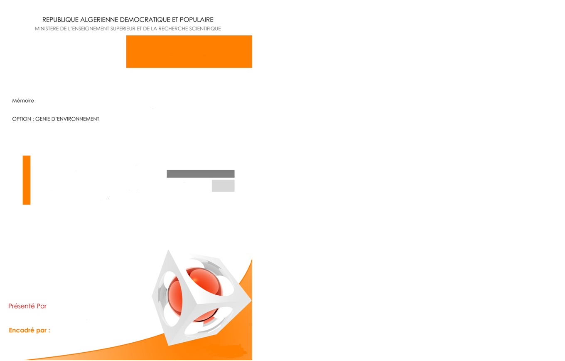

**Valorisation of residues FROM SUPERCRITICAL EXTRACTION INTO value added products for water treatment.**

**Présenté par : Dirigé par :**

**BENHAMOUDA Abderrahmane Farouk Pr. ARRIS Sihem**

**DJALOUDI Mouad Abdelmoumen**

**SAKHRI Hitem**

**Année universitaire**

**2023-2024**

**Session : juin**

**Acknowledgements**

First, we express our gratitude to Allah for granting us the strength, perseverance and wisdom to complete this work.

In these circumstances, it is fitting to offer our heartfelt thanks to everyone who, in a way or another, has contributed to the completion of this thesis.

We would like to begin by expressing our deepest gratitude to our advisor, **Pr.Arris Sihem**, whose unwavering support, insightful guidance, and invaluable expertise have been fundamental to the successful completion of our graduation thesis. Their patience, encouragement, and profound knowledge have been a constant source of inspiration and motivation throughout our research journey.

We would also like to extend our heartfelt thanks to our fellow classmates and friends in Lab, the stimulating discussions, collaborative efforts, and collective problem-solving sessions have not only enhanced our understanding but also made this journey enjoyable and memorable. The camaraderie and mutual support we shared during the late-night study sessions and tight deadlines were invaluable.

Furthermore, we are deeply appreciative of the administrative and technical support provided by our department of environmental engineering. Special thanks to the lab engineer **Karima** and the four PhD students **Halima**, **Amina**, **Yasser** and **Aya**, whose assistance and resources were instrumental in facilitating our research and ensuring a smooth workflow.

A special note of thanks to our professors and mentors who have guided us throughout our academic journey. Their dedication to teaching and mentoring has profoundly shaped our knowledge and skills.

Last but certainly not least, we owe a profound debt of gratitude to our families. Their unwavering belief in our abilities, constant encouragement, and unconditional support have been our bedrock. To our parents, your love and sacrifices have been our driving force, and we dedicate this achievement to you.

**Dedication**

First, to God have mercy and bless us

To parents for their patience, support, and sacrifices.

To brothers and sisters and friends for their collaborations and encouragement.

To our education supervisor, a thousand thanks for sharing your

knowledge, wisdom, wonderful advice, and encouragement.

**Contents**

General introduction.………………………………………………………………......1

1 Chapter 1: Water pollution and treatment methods 4

1.1 Wastewater 5

1.1.1 Contaminants in Wastewater 5

1.1.2 Emerging water pollutants 6

1.2 Wastewater treatment 8

2 Chapter 2: bio-adsorption 10

2.1 Adsorption 10

2.1.1 Type of bioadsorbent 10

2.1.2 Types of adsorptions 12

2.1.3 Mechanisms of the Adsorption 13

2.1.4 Parameters influencing the adsorption phenomenon 14

3 Chapter 3: Coagulation-Flocculation 15

3.1 Coagulation-Flocculation 15

3.2 Principle of coagulation flocculation 15

3.2.1 Coagulation 15

3.2.2 Flocculation 16

3.3 Theory of the double layer 16

3.4 Theoretically possible strategies 19

3.5 Factors influencing coagulation 19

3.5.1 Coagulant Type and Dosage 20

3.5.2 Water Quality Parameters 20

3.5.3 Mixing and Flocculation 20

3.5.4 Other Factors 21

3.5.5 Conventional coagulants 21

3.5.6 The choice of coagulant 22

3.6 Biocoagulants and bioflocculents 23

3.6.1 Advantages of Biocoagulants 23

4 Chapter 4: Supercritical fluid extraction 25

4.1 Supercritical extraction 25

4.2 Supercritical fluid extraction 25

4.3 Properties of supercritical fluid 26

4.4 Supercritical carbon dioxide 26

4.5 Environmental improvement and reduced product contamination 27

5 Chapter 5: Valorization of plant residues 28

5.1 Valorization of residues plants 28

5.1.1 Energy valorization 28

5.1.2 Biofertilizer 29

5.1.3 Extraction of valuable compounds 30

5.1.4 Animal Feed 32

5.1.5 Soil Erosion Control 32

5.1.6 Bioremediation 33

6 Chapter 6 Material and methods 35

6.1 Potential Health Benefits (limited research) 35

6.2 Residue of supercritical CO2 extraction of oil from onion seeds 36

6.2.1 Extracting Valuable Compounds: 36

6.2.2 Direct Use of the Residue: 36

6.3 Benefits of SC-OSE Residue Valorization: 36

6.4 Product and equipment used: 37

6.4.1 Products 37

6.4.2 Methyl Green Dye and its Impact 40

6.4.3 Materials 42

6.5 Experimental procedures 48

6.5.1 Adsorption procedure 48

6.5.2 Biocoagulation/Bioflocculation Experiment (Jar test) 49

6.6 Characterization of Oil supercritical Extract Residue (OSER) 50

6.6.1 Identification and Dosage of Surface Functions Using the Boehm Method 51

6.6.2 pH at the point of zero charge: 52

6.6.3 Iodine index 54

6.6.4 Methylene blue index 55

6.6.5 Phenol index 57

6.7 Results of FTIR characterization of OSER before and after treatment 57

7 Chapter 7 Results and discussion 61

7.1 Effect of dosage of OSER 61

7.2 Effect of flocculent 63

7.3 Effect of pH 64

7.4 Adsorption study 67

7.4.1 Effect of dosage 67

7.4.2 Influence of contact time 69

7.5 Kinetic study 71

7.5.1 Pseudo-first-order kinetic 71

7.5.2 The pseudo-second-order kinetics 72

7.6 Intraparticle diffusion model 75

7.7 Effect of initial pH 79

7.8 Effect of initial concentration 82

7.9 Effect of temperature 84

7.10 Isotherm study 86

7.10.1 Langmuir isotherm 87

7.10.2 Freundlich isotherm 89

7.10.3 Temkin isotherm 91

7.10.4 Dubinin-Radushkevich isotherm 92

7.11 Thermodynamic study 94

Conclusion……………………………………………………………………………..97

**2015/2016**

**List of Figures**

Figure 1 Adsorption process 13

Figure 2 Theory of double layer 17

Figure 3 Variation of Nernst potential for a single colloidal particle 18

Figure 4 Coagulation process 19

Figure 5 The biorefinery concept for valorization of crop residues 34

Figure 6 Powder of OSER 37

Figure 7 Crystal violet 39

Figure 8 Crystal violet calibration curve 39

Figure 9 Methyl green 40

Figure 10 Methyl green calibration curve 42

Figure 11 Thermometer 42

Figure 12 pH meter 43

Figure 13 Magnetic agitator 43

Figure 14 Centrifuge 44

Figure 15 Drying oven 45

Figure 16 UV-Visible spectrometry 46

Figure 17 Jar test 47

Figure 18 The FTIR (Fourier Transform Infrared) 48

Figure 19 pH zero charge of OSER 54

Figure 20 FTIR Spectrum of OSER before and after adsorption and coagulation 58

Figure 21 Effect of OSER dosage on the concentration 62

Figure 22 Effect of OSER dosage on the yield 62

Figure 23 Effect of clay dosage and industrial polymer dosage on yield 63

Figure 24 Yield of OSER and Different Flocculants 63

Figure 25 Concentration initial and concentration rested of using OSER and Different Flocculants 64

Figure 26 Effect of pH on the yield 65

Figure 27 Effect of pH on concentration 65

Figure 28 Effect of dosage of OSER on the capacity 67

Figure 29 Effect of dosage of OSER on the yield 68

Figure 30 Retention capacity with different masses utilized 69

Figure 31 Effect of contact time on the capacity 70

Figure 32 Effect of contact time on the yield 70

Figure 33 The pseudo-first-order kinetic model of biosorption of crystal violet on OSER 72

Figure 34 The pseudo-second-order kinetic model of biosorption of crystal violet 73

Figure 35 Intraparticle diffusion 76

Figure 36 The intraparticle diffusion on different phases 77

Figure 37 Effect of initial pH on the adsorption capacity of CV by OSER 80

Figure 38 Effect of initial pH on the yield of biosorption of CV by OSER 80

Figure 39 The different initial pH with the equivalent qe 81

Figure 40 Zwitterionic Form of crystal violet 81

Figure 41 Effect of initial concentration on the adsorption capacity 83

Figure 42 Effect of initial concentration on the yield of the adsorption by OSER 83

Figure 43 The different initial concentrations with the equivalent qe 84

Figure 44 Effect of temperature on biosorption of CV by OSER. 85

Figure 45 The different temperatures with the equivalent qe 85

Figure 46 Isotherm biosorption of CV on OSER 86

Figure 47 The 5 types of Langmuir isotherm 88

Figure 48 Freundlich isotherm 89

Figure 49 Temkin model 91

Figure 50 Dubinin-Radushkevich model 93

Figure 51 Thermodynamic plot 94

**List of Tables**

Table 1Nature of interaction and interparticle distance 18

Table 2 Determination of Surface Functions 52

Table 3 pH zero charge 53

Table 4 Results of methylene blue index 56

Table 5 Results of Phenol index 57

Table 6 FTIR results of OSER before and after adsorption and coagulation 59

Table 7 Constants of the pseudo-first-order kinetic model 74

Table 8 Constant of intraparticle kinetic model 78

Table 9 Constants of Langmuir and Freundlich isotherm 90

Table 10 Temkin constants 91

Table 11 Dubinin-Radushkevich constants 93

Table 12 Constants of Thermodynamic study 95

**Abbreviation**

|  |  |
| --- | --- |
| AD | anaerobic digestion |
| As | arsenic |
| BOD | biochemical oxygen demand |
| C | concentration (mg/L) |
| Cd | cadmium |
| Cm | centimeter |
| Cr | chromium |
| Cu | copper |
| CV | Crystal violet |
| D | diameter |
| FTIR | Fourier transform infrared |
| G | gram |
| Hg | mercury |
| λ | wavelength |
| L | litre |
| m | mass |
| MG | Methyl green |
| ml | millilitres |
| Ni | nickel |
| nm | nanometre |
| OSER | onion seeds extract residue |
| PAHs | polycyclic aromatic hydrocarbons |
| % | percentage |
| Pb | lead |
| Pc | critical pressure |
| PCBs | polychlorinated biphenyls |
| pH | potential of hydrogen |
| pHPzc | the point of zero charge |
| R | yields |
| SFE | supercritical extraction |
| T | temperature |
| t | time |
| Tc | critical temperature |
| TSS | total suspended solids |
| UV | ultraviolet |
| V | volume |
| Zn | zinc |

**General introduction**

**General introduction**

Water is a vital resource for all forms of life on Earth. However, water pollution has become a major concern on both a global and local scale, with sources ranging from industrial and agricultural discharges to domestic waste. Industrial activities often release heavy metals and toxic chemicals, while agricultural runoff contributes pesticides and fertilizers to water bodies. Domestic waste, including untreated sewage, further compounds the issue, leading to significant repercussions on human health and the environment. Consuming contaminated water can lead to diseases like gastrointestinal infections, parasitic diseases, and even cancer. Chemical contaminants such as heavy metals (e.g., lead, mercury) and pesticides can accumulate in the body, causing long-term health issues and developmental problems.

Aquatic environments suffer greatly from water pollution. Marine and freshwater ecosystems are disrupted, leading to a decrease in biodiversity. Fish and other aquatic organisms are often poisoned by pollutants, which can also affect the food chain. Wetlands, which are crucial for natural water filtration and provide habitat for numerous species, are frequently degraded by pollutants, reducing their ability to support wildlife and mitigate flooding.

In Algeria, water pollution is exacerbated by rapid industrial growth and inadequate wastewater treatment infrastructure. Industrial facilities often discharge untreated or poorly treated effluents into rivers and groundwater, contaminating water sources. Agricultural activities contribute to pollution through runoff that carries pesticides, herbicides, and fertilizers into water bodies. This pollution poses serious risks to local populations, leading to health problems and reducing the availability of clean water for drinking and irrigation.

Additionally, dyes used in the textile, food, and pharmaceutical industries contribute significantly to water pollution. These substances are often discharged into water systems without proper treatment, resulting in harmful effects on aquatic flora and fauna. Dyes can reduce light penetration in water, disrupting photosynthesis in aquatic plants. Some dyes are carcinogenic and mutagenic, posing serious health risks to humans upon exposure.

Green waste, primarily from agricultural activities, public and private gardens, and the agro-food industry, represents a substantial source of biomass that can be valorized for ecological applications. The zero-waste procedure aims to minimize waste production and maximize reuse and recycling. This approach includes source reduction, material reuse, recycling, and the valorization of organic waste through composting or methanization. By converting green waste into valuable products, we can reduce the environmental impact of waste and promote sustainability.

Our biomaterial is a residue from the supercritical extraction of onion seed (**OSER**) Onion Seed Extract Residue), carried out as part of an International PRIMA project affiliated to the Environmental Process Engineering Laboratory, Faculty of Engineering Process, University Constantine 3.

Onion residues, often considered waste, can be valorized as coagulant, flocculant, and biosorbent in wastewater treatment. These residues contain natural compounds, such as flavonoids and phenolic acids, capable of binding and precipitating suspended particles in water, as well as adsorbing contaminants like heavy metals and dyes. This process improves water quality by removing impurities and reducing turbidity. Plant-based coagulants, flocculants, and adsorbents like onion extraction residues offer several advantages. They are biodegradable, non-toxic, and provide a sustainable alternative to synthetic chemicals. Moreover, their adsorption capabilities enhance the removal of dissolved pollutants and toxins, making them effective in treating complex wastewater mixtures.

Our study will demonstrate the effectiveness of onion residues in these roles through a series of experiments. We will present the results of their application in wastewater treatment, showcasing their potential to improve water quality. These findings will highlight the viability of using onion extraction residues as a natural and sustainable solution for water treatment, reducing environmental impact and promoting the circular economy by converting waste into valuable resources.

In this work, we will discuss the use of onion extraction residues as sorbent to removal crystal violet and as bio coagulant to removal green methyl from aqueous solutions.

Our manuscript is presented as following:

The first part of the study presented in this manuscript is dedicated to an overview of the water pollution and the various methods for treating this type of liquid effluent. A brief specification for crystal violet and green methyl, which are two of the elements considered in this research, was also discussed in this part. The two used methods namely adsorption and coagulation are also discussed.

The second chapter of this document is dedicated to presenting the material used in this study, as well as the different methods of analysis and characterization. The experimental procedures implemented in the laboratory have also been detailed.

All experimental results obtained, as well as their discussions, have been grouped and interpreted in detail in the last chapter, which constitutes the crucial part of this manuscript.

**Chapter Ⅰ**

**Water pollution and treatment methods**

# ****Chapter 1: Water pollution and treatment methods****

**INTRODUCTION**

**t**he shortage of fresh water is a global problem, and human activities like industrial operations, agriculture, and household usage are contributing to water contamination, causing growing concern. The rapid expansion of the human population, along with industrialization and urbanization, has led to increased water pollution and a shrinking supply of clean water. Wastewater contains a mix of organic and inorganic contaminants, with different sources producing different pollutants. Various methods are used to treat and purify water to make it safe for environmental release, human consumption, or other uses. The primary aim of wastewater treatment is to remove inorganic salts, organic compounds, suspended solids and actually recalcitrant pollutants and micro plastics considering as modern pollution. Several treatment methods exist, but many faces significant challenges, including high costs. This has created a need for more reliable and cost-effective solutions for treating wastewater [1].

The valorization of waste in the environment is a crucial concept in sustainable resource management. By valorizing waste, we can transform it into valuable resources through recycling, upcycling, or energy recovery processes. This not only helps to reduce the amount of waste that ends up in landfills but also contributes to the conservation of natural resources and the reduction of environmental pollution. By implementing effective waste valorization strategies, we can create a more circular economy where waste is seen as a valuable resource rather than a disposable burden on the environment.

The use of vegetal residue in water treatment is a sustainable and effective method to purify water. Vegetal residue, such as plant material and organic waste, can be used as a natural filter to remove impurities and contaminants from water. This process, known as phytoremediation, is environmentally friendly and can help improve water quality without the need for harsh chemicals. By utilizing vegetal residue in water treatment, we can promote an eco-friendlier approach to managing water resources.

## Wastewater

Wastewater is the collection of water, solids, and liquids released into sewers, resulting from the waste produced by communities. It includes both dissolved and suspended organic materials, which can break down biologically or decompose. Wastewater is typically divided into two major but sometimes overlapping types: domestic and industrial [2].

### Contaminants in Wastewater

#### Metals

The expansion of human activity and industry, such as the plating and electroplating sector, batteries, pesticides, mining, rayon, metal rinse processes, tanning, textile, metal smelting, petrochemical, paper, and electrolysis applications, has resulted in an increase in the presence of heavy metals in wastewater. Lead (Pb), zinc (Zn), mercury (Hg), nickel (Ni), cadmium (Cd), copper (Cu), chromium (Cr), and arsenic (As) are the most commonly occurring heavy metals [3].

#### Nitrogen and Phosphorus Compounds

Nutrients are defined as those elements that are necessary for the growth and vitality of living things, such as phosphorous and nitrogen. Nevertheless, eutrophication occurs when waste streams rich in nutrients are released into aquatic environments. Consequently, in order to comply with the stringent nutrient discharge regulations, wastewater must have its nutrients removed. Likewise, in order to prevent the depletion of limited resources, nutrient recovery from waste streams is essential to the implementation of a circular economy [4].

#### Total Solids

One of the main contaminants that are thought to be responsible for the decline in water quality and the subsequent increase in water treatment expenses is total suspended solids (TSS) [5].

#### Microorganisms

Wastewater streams contain many different types of pathogens that present a major health risk. Human pathogens include bacteria, viruses, parasitic protozoans, and helminths. Pathogens can enter wastewaters from many sources [6].

### Emerging water pollutants

For the past two decades, numerous articles have documented the occurrence of novel compounds known as “emerging pollutants’ in wastewater and aquatic ecosystems. These emerging pollutants consist of new substances of chemicals that lack regulatory classification and their impact on the environment and human health remains uncertain. The more widely known emerging pollutants are listed below [7].

#### Microplastic

The increasing presence of microplastic and synthetic microfiber particles in the environment is predominantly attributed to various human activities. Poor management and widespread release of these minute pollutants are causing contamination in habitats and ecosystems worldwide. Major contributors to the pollution in aquatic systems include the laundering of synthetic fabrics, improper disposal of single-use plastic items, industrial operations, microbeads from cosmetics, tire abrasion, and the breakdown of larger plastic objects. Urban sewage treatment plants serve as significant receptors of these synthetic polymer pollutants, with estimates suggesting a substantial influx of particles per liter of water. Scientific assessments indicate that a staggering 5 trillion persistent particles already exist in the ocean, with projections indicating a further increase in the future, potentially reaching 50 tons of plastic particles entering the ocean per minute by 2050. The actual quantity of these particles, including those that go unnoticed, is presumed to be significantly higher than currently observed. Efforts are underway to address the integration of these microparticles into aquatic environments and the threats they pose to both aquatic and terrestrial ecosystems. Conventional wastewater treatment methods are ineffective in removing these tiny pollutants due to their size, leading to their widespread distribution in rivers and oceans. Various physical and biological treatment techniques, such as filtration, membrane bioreactors, flotation, microbial degradation, and enzymatic digestion, are being employed for efficient remediation of these emerging pollutants. The escalating presence of micro-pollutants in diverse ecosystems has garnered considerable attention from researchers and the general public, fueled by mounting evidence of their adverse effects [8].

#### Pharmaceutical and personal care products (PPCPs)

The presence of toxic chemicals in pharmaceutical wastewater raises significant concerns, demanding proper treatment and disposal methods to protect human health and the environment. These chemicals, which include active pharmaceutical ingredients, antibiotics, solvents, and organic compounds, exhibit various harmful properties such as toxicity, flammability, and carcinogenicity, thereby posing risks to living organisms and ecosystems. Additionally, contaminants like surfactants, emulsifiers, residual drugs, and metabolites further complicate the composition of pharmaceutical wastewater. Conventional treatment technologies such as activated carbon adsorption, oxidation processes, membrane filtration, and biological treatment have limitations in effectively removing or neutralizing these hazardous substances when employed individually for the safe disposal of pharmaceutical wastewater [9].

#### Surfactants

Another diverse group of chemicals, known as surfactants or surface-active agents, can be structurally divided into two parts: a polar, water-soluble head and a nonpolar hydrocarbon tail that is insoluble in water. Surfactants are prized for their high solubility and cleaning abilities, making them highly valued among detergents and other cleaning substances [10].

#### Endocrine Disruptors (EDCs)

Endocrine disrupting compounds (EDCs) represent a growing class of environmental micropollutants that contribute significantly to environmental pollution and subsequently impact wildlife and public health. Their hormone-like properties pose serious concerns. EDCs are characterized as "agents that disrupt the synthesis, secretion, transport, binding, action, or elimination of natural hormones in the body, which are vital for maintaining homeostasis, reproduction, development, and behavioral patterns." The Endocrine Society further defines EDCs as "exogenous (non-natural) chemicals or mixtures thereof that interfere with any aspect of hormone action [11].

#### Phthalates

Phthalates, di-esters of phthalic acid, have served as plasticizers since the 1930s for a diverse range of applications, including PVC plastics manufacturing, packaging materials, personal care products, children's toys, and medical devices. These compounds are typically not chemically bonded to plastic polymers, allowing them to readily migrate and leach from plastics into food and water. As a result, phthalates are widespread environmental contaminants present in air, surface water, marine environments, soil, wastewater, and sludge from wastewater treatment plants, as well as in various organisms. The environmental release of phthalates can occur during the production, use, and disposal of plastic-based products [12].

#### Dyes

Dyes released from industrial processes, particularly the textile industry, can have significant negative effects on the environment. Here's a breakdown of some key concerns:

* **Reduced light penetration**: Dye effluent can significantly discolor water bodies, reducing light penetration. This disrupts photosynthesis for aquatic plants, which are the base of the food chain in many ecosystems.
* **Impact on aquatic life:** Reduced plant growth due to light blockage can disrupt the entire food chain. Additionally, some dyes can be directly toxic to fish and other aquatic organisms.
* **Oxygen depletion:** The breakdown of dyes by microorganisms can increase Biochemical Oxygen Demand (BOD) in water. This means more oxygen is used by these microbes, leaving less available for fish and other aquatic life.
* **Persistence in the environment:** Many synthetic dyes are complex molecules that resist natural degradation. This means they can persist in the environment for long periods, continuing their harmful effects.
* **Difficult treatment:** Conventional wastewater treatment methods often struggle to remove dyes completely. This necessitates the development of more effective treatment solutions.

The textile industry is a major culprit when it comes to dye effluent, but other industries can also contribute. Stricter regulations and the adoption of eco-friendly dyes are crucial steps towards minimizing the environmental impact of these pollutants.

## Wastewater treatment

Water treatment encompasses employing various methods, including biological, chemical, physical, and physicochemical processes, to mitigate and eliminate toxins and contaminants from water. The primary aim of water treatment is to obtain water with suitable properties for its intended applications. Consequently, the water treatment process varies depending on the characteristics of the water source. The recovery and reuse of water from diverse sources such as stormwater, greywater, and wastewater can enhance water efficiency and alleviate the impacts of water scarcity [13].

Several methods are used in industrial wastewater treatment to eliminate dyes:

* **Ion Exchange:**

This method involves swapping ions in the dye molecules with other ions, altering their structure and allowing for removal.

* **Adsorption:**

Highly effective and versatile, this process uses adsorbent materials like activated carbon, bio-adsorbents (algae, agricultural waste), or synthetic polymers to attract and trap dye molecules on their surface. It's efficient and relatively simple.

* **Coagulation-Flocculation:**

This method destabilizes dye particles in the water using coagulants (chemicals that cause particles to clump together) followed by flocculants (agents that bridge the clumps). The larger flocs then settle out for removal.

* **Membrane Filtration:**

Techniques like reverse osmosis or ultrafiltration utilize specialized membranes with tiny pores that allow water molecules to pass through while retaining dye molecules. This can also recover clean water and potentially the dyes for reuse.

* **Chemical Oxidation:**

This approach uses strong oxidizing agents like chlorine or ozone to break down dye molecules into simpler, less harmful compounds. However, it may generate harmful byproducts and requires careful control.

* **Biological Treatment:**

Certain microorganisms can degrade some dyes under specific conditions. This method is less common but offers a potentially sustainable option.

**Chapter Ⅱ**

**Bio-adsorption**

# ****Chapter 2: bio-adsorption****

## Adsorption

Adsorption is a phenomenon wherein a molecule or ion present in a gaseous or liquid bulk phase adheres to a solid surface. It involves a change in the concentration of a given substance at the interface compared to neighboring phases. The molecules on the surface are called the "adsorbate," while the solid is the "adsorbent." This sticking happens on both the outer and inner surfaces of the solid, formed by pores and cavities. It involves molecules attaching to the surface, forming a layer. Adsorption occurs due to different interactions between fluid molecules and the solid surface, like van der Waals forces, electrostatic interactions, and hydrogen bonding. Adsorption can take place in various systems, including solid-liquid, solid-gas, liquid-gas, and liquid-liquid interfaces, and is widely utilized in industrial wastewater treatment. For example, adsorption can effectively remove and recover heavy metals from wastewater, even at low concentrations. Consequently, adsorption represents a practical and straightforward approach in wastewater treatment compared to other methods. Various parameters, such as pH, adsorbent dose, temperature, contact time, concentration, and the properties of the adsorbent's surface play crucial roles in determining the effectiveness of adsorption techniques [14]. Various models describe adsorption, including isotherms and kinetics [15].

### Type of bioadsorbent

#### Plant-Based Bioadsorbents

Plant-based bioadsorbents are derived from various parts of plants including leaves, stems, roots, and fruit peels. These bioadsorbents are characterized by their high surface area, porous structure, and abundance in nature. They have been extensively studied for their effectiveness in removing pollutants such as heavy metals, dyes, and organic compounds from aqueous solutions. Plant-based bioadsorbents offer a sustainable and cost-effective solution for pollution control, utilizing renewable resources and minimizing environmental impact [16] [17].

#### Algae-Based Bioadsorbents

Algae-based bioadsorbents utilize different types of algae, including macroalgae (seaweeds). Algae possess cell walls rich in polysaccharides and functional groups such as carboxyl, hydroxyl, and amino groups, which facilitate adsorption processes. These bioadsorbents have demonstrated effectiveness in removing heavy metals, nutrients, and organic pollutants from wastewater. Algae-based bioadsorbents are renewable, fast-growing, and can be cultivated in both freshwater and marine environments, making them a sustainable option for pollution control [18].

#### Microbial-Based Bioadsorbents

Microbial-based bioadsorbents consist of microorganisms such as bacteria, fungi, Microbial cells and their extracellular products; can adsorb pollutants through physical and chemical interactions. These bioadsorbents exhibit high specificity and selectivity for certain contaminants and can be engineered for enhanced adsorption capacity. They have been employed in various applications, including the removal of heavy metals, hydrocarbons, and pharmaceuticals from wastewater. Microbial-based bioadsorbents offer a promising avenue for pollution control, leveraging the unique properties of microorganisms for environmental remediation [19].

#### Biopolymeric Bioadsorbents

Biopolymeric bioadsorbents are composed of natural polymers such as chitosan, cellulose, and these polymers possess functional groups, including amino and hydroxyl groups, that enable interactions with pollutants through electrostatic attraction, coordination, and hydrogen bonding. Biopolymeric bioadsorbents are biodegradable, non-toxic, and can be modified for specific applications through chemical or physical treatments. They have been utilized for the removal of heavy metals, dyes, and organic pollutants from aqueous solutions. Biopolymeric bioadsorbents offer a sustainable and environmentally friendly approach to pollution control, utilizing biodegradable materials for adsorption processes [20] [21].

#### Nanomaterial-Based Bioadsorbents

Nanomaterial-based bioadsorbents consist of nanoscale materials such as carbon nanotubes, graphene oxide, and metal nanoparticles. These materials possess large surface-to-volume ratios and unique physicochemical properties that enhance adsorption capacity and selectivity. Nanomaterial-based bioadsorbents can be functionalized with biomolecules or surface modifiers to enhance pollutant adsorption and facilitate recovery and reuse. They have shown promise in removing heavy metals, emerging contaminants, and nanoparticles from water and wastewater streams. Nanomaterial-based bioadsorbents represent an innovative approach to pollution control, utilizing nanotechnology for efficient and targeted removal of pollutants from the environment [22].

### Types of adsorptions

#### Physical Adsorption

Physical adsorption, also known as physisorption, occurs when molecules of a pollutant are attracted to the surface of a bioadsorbent through weak van der Waals forces or electrostatic interactions. This process involves the accumulation of pollutants on the surface of the bioadsorbent without the formation of chemical bonds. The adsorption capacity is influenced by factors such as surface area, pore size distribution, and surface chemistry of the bioadsorbent. Physical adsorption is reversible and typically occurs rapidly, making it an important mechanism for pollutant removal in environmental remediation applications [15].

#### Chemical Adsorption

Chemical adsorption, or chemisorption, entails the establishment of chemical bonds between pollutant molecules and the surface functional groups of the bioadsorbent. This occurs through chemical reactions at reactive sites on the bioadsorbent, like hydroxyl, carboxyl, amino, or sulfhydryl groups. Chemisorption typically yields stronger and more enduring bonds than physical adsorption, resulting in increased adsorption capacities and selectivity for particular pollutants. Nonetheless, chemical adsorption processes may proceed at a slower pace and necessitate specific environmental conditions, such as pH and temperature, for optimal efficiency [15].

### Mechanisms of the Adsorption

* **External diffusion:**  This refers to the transference of solute molecules from the liquid phase to the external surface of particles. The rate of this external mass transfer is contingent upon the hydrodynamic characteristics of fluid flow within a bed of adsorbent [23].
* **Internal diffusion:** Fluid particles penetrate into the pores, driven by the concentration gradient of the solute [23].
* **Surface diffusion:** This refers to the attachment of molecules to the surface of the pores.

These processes collectively drive adsorption, moving and gathering adsorbate molecules on the material's surface. External diffusion shifts solute molecules from the bulk solution to the outer surface, affected by flow rate and particle size. Internal diffusion sees molecules diffuse into pores, driven by concentration gradients. Surface diffusion involves molecule migration along pore surfaces, aiding adsorption. Understanding these mechanisms optimizes adsorption in wastewater treatment, gas purification, and separation [23].

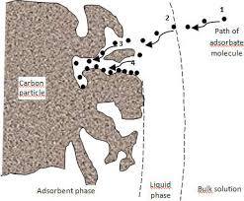

Figure 1 Adsorption process

### Parameters influencing the adsorption phenomenon

* **Specific Surface Area:** The specific surface area, or massive area, denotes the total surface area accessible to atoms and molecules per unit mass of the substance. It's a vital factor that impacts adsorption processes [24].
* **pH:** pH greatly influences adsorption properties, with optimal outcomes often seen at lower levels, especially for adsorbing acidic substances [24].
* **Concentration:** For low dissolved concentrations, adsorption rates generally follow the Freundlich law [24].
* **Adsorption Rate:** Adsorption in the liquid phase typically occurs more slowly in physical processes. The solution's viscosity plays a role in the adsorption rate, and reducing viscosity, often achieved through heating, is likely to accelerate the process [24].
* **Nature of the Adsorbent and adsorbate:** Adsorbents operating in the liquid phase typically exhibit distinct characteristics compared to those used in the gas phase due to the movement of substances in a more or less viscous solvent [24]. The physicochemical properties of the adsorbate are pivotal and greatly influence its adsorption onto the solid surface of the adsorbent. The molecular structure stands out as one of the primary parameters determining the retention of adsorbate [24].
* **Temperature:** Adsorption typically releases heat, making it an exothermic process, and lowering the temperature generally favors its progression, although exceedingly rare instances of endothermicity have been documented [24].

**Chapter Ⅲ**

**Coagulation-Flocculation**

# ****Chapter 3:**** ****Coagulation-Flocculation****

## Coagulation-Flocculation

Coagulation and flocculation are integral parts of water and wastewater treatment units, aimed at removing suspended particles. In these processes, the selection of coagulants and flocculants plays a pivotal role. The principle underlying coagulation and flocculation involves destabilizing suspended particles through the addition of coagulants and flocculants, which reduces the repulsive forces between particles, thus facilitating floc formation under stable conditions. Once destabilized, the particles collide and aggregate to form larger flocs, which are more easily precipitated. Established chemical coagulants and flocculants are commonly employed in raw water and wastewater treatment due to their demonstrated high efficiency in removing suspended particles [21].

## Principle of coagulation flocculation

### [Coagulation](https://sswm.info/content/coagulation)

Coagulation destabilises the particules’ charges. Coagulants with charges opposite to those of the suspended solids are added to the water to neutralize the negative charges on dispersed non-settable solids such as clay and organic substances. Once the charge is neutralized, the small-suspended particles are capable of sticking together. The slightly larger particles formed through this process are called microflocs and are still too small to be visible to the naked eye. A high-energy, rapid-mix to properly disperse the coagulant and promote particle collisions is needed to achieve good coagulation and formation of the microflocs. Over-mixing does not affect coagulation, but insufficient mixing will leave this step incomplete. Proper contact time in the rapid-mix chamber is typically 1 to 3 minutes [25].

### Flocculation

Following coagulation, flocculation, a gentle mixing stage, increases the particle size from submicroscopic microfloc to visible suspended particles.

The microflocs are brought into contact with each other through the process of slow mixing. Collisions of the microfloc particles cause them to bond to produce larger, visible flocs. The floc size continues to build through additional collisions and interaction with inorganic polymers formed by the coagulant or with organic polymers added. Macroflocs are formed. High molecular weight polymers, called coagulant aids, may be added during this step to help bridge, bind, and strengthen the floc, add weight, and increase settling rate. Once the floc has reached its optimum size and strength, the water is ready for the separation process ([sedimentation](https://www.sswm.info/sswm-university-course/module-2-centralised-and-decentralised-systems-water-and-sanitation-2/sedimentation-(centralised)), floatation or filtration). Design contact times for flocculation range from 15 or 20 minutes to an hour or more [25].

## Theory of the double layer

When a colloidal particle is suspended in a polar medium containing ion, it electrostatically attracts ions of opposite charge. Consequently, in the vicinity of the charged particle, electric charges carried by ions are distributed into two layers, as illustrated in the figure below. The different species present in the solution are encountered in the following order:

* the particle, often negatively charged in nature;
* A fixed layer of ions of opposite sign (Stern layer);
* A diffuse layer of counter-ions, decreasing in density with distance, deformable and mobile (Gouy layer);
* The mass of the surrounding liquid.

Between these two layers, there exists an electrostatic or Nernst potential, which varies depending on the distance from the surface of the colloid.

In the bound layer, the Nernst potential decreases linearly because the constituent cations are uniformly stacked. However, in the Gouy layer, the electrostatic potential varies nonlinearly, as the ionic distribution results from a random mixture of cations and anions.

The value of the potential at the surface of the Nernst layer is called the zeta potential. Since colloids are negatively charged, this potential is negative. In natural waters, its value varies from -30 to -35 mV. Particles with negative zeta potential repel each other strongly. Therefore, colloids are very stable and inhibit any aggregation [25].

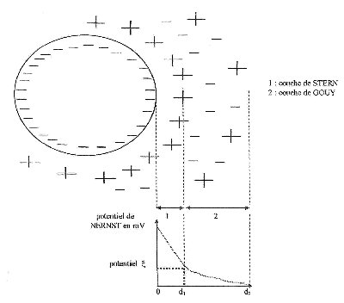

Figure 2 Theory of double layer

The existence of colloidal systems depends on the interaction between two particles. It involves two opposing forces:

* A repulsive force that tends to push the particles apart. This force depends on the charge of the particles, which are of the same sign
* An attractive force (Van der Waals type) that tends to bring the particles together to reach the minimum potential energy. This force is, of course, dependent on the distance between particles

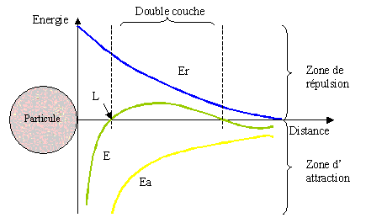

Figure 3 Variation of Nernst potential for a single colloidal particle

Table 1Nature of interaction and interparticle distance

|  |  |
| --- | --- |
| **Interparticle distance** | **Interpretation** |
| d>d3  d3<d<d2  d2<d<d1  d<d1 | No interaction Weak attraction Repulsion Strong attraction  adhesion |

To enable particle adhesion, the energy barrier of repulsion must be overcome:

* Either by increasing the kinetic energy of the particles
* Or by lowering the repulsion barrier

In the first case, one would need to increase the agitation of the particles by raising the temperature, which is not feasible for the volumes of water to be treated.

In the second case, it is necessary to nullify the electrostatic repulsion forces, thus the zeta potential

## Theoretically possible strategies

To nullify the zeta potential, one can:

* Adjust the pH to reach the point of zero charge of colloidal particles
* Increase salinity to compress the diffuse layer
* Neutralize the surface charge by polyvalent cations
* Trap colloids in precipitates
* Adsorb colloids onto long-chain charged polymers

Given the quantities to be treated, the first two options are not applicable at an industrial level. Chemical coagulation, through the addition of trivalent cations, is therefore the best solution [25].

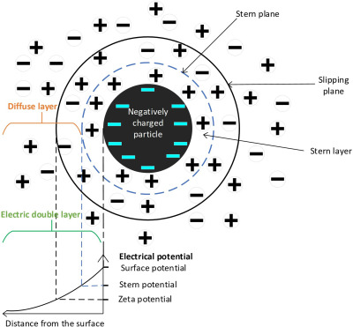

Figure 4 Coagulation process

## Factors influencing coagulation

Several factors influence how effectively coagulation occurs in water treatment:

### Coagulant Type and Dosage

* Coagulant Selection: Different coagulants, like aluminum sulfate (alum) or ferric chloride, work better for specific types of contaminants in the water. The choice depends on the water's characteristics and the desired outcome.
* Dosage Optimization: The amount of coagulant added is crucial. Too little won't destabilize enough particles, and too much can lead to restabilization and hinder removal. Pilot testing helps determine the optimal dosage.

### Water Quality Parameters

* pH: Water acidity (pH) significantly impacts how coagulants work. Each coagulant has a specific pH range for optimal performance. Adjusting pH might be necessary for effective coagulation.
* Temperature: Colder temperatures generally slow down coagulation rates. Warmer water can improve the process but may require adjustments to other parameters.
* Turbidity and Organic Matter: The amount of suspended solids and organic matter in the water affects how much coagulant is needed. Higher levels require a higher dosage.
* Alkalinity and Hardness: The presence of minerals like calcium and magnesium can affect how well coagulants destabilize particles. Water with high alkalinity or hardness might need adjustments in coagulant type or dosage.

### Mixing and Flocculation

* Rapid Mixing: After adding the coagulant, rapid mixing is essential to disperse it evenly throughout the water and ensure good contact with the particles.
* Slow Mixing (Flocculation): Gentle mixing after rapid mixing allows the destabilized particles to collide and form larger flocs for efficient removal during sedimentation or filtration.

### Other Factors

* Presence of interfering substances: Certain chemicals in the water can hinder coagulation, requiring adjustments or alternative methods.
* Desired removal efficiency: The goal might be complete removal of all suspended solids or just a significant reduction in turbidity. This can influence coagulant selection and dosage.

### Conventional coagulants

Coagulants are substances that neutralize or reverse the surface charges of materials

The main coagulants used to destabilize particles and produce flocs are:

* Aluminum sulfate Al2(SO4)3, 18 H2O
* Sodium aluminate NaAlO2
* Ferric chloride FeCl3, 6 H2O
* Ferric sulfate Fe2(SO4)3, 9 H2O
* Ferrous sulfate FeSO4, 7 H2O.
* Copper sulfate
* Agar-Agar
* Moringa oleifera seeds
* Pinus halepensis Seeds

The effectiveness of these coagulants is directly related to the valence of the cations used. Thus, a divalent ion can be up to 200 times more effective, and a trivalent ion up to 10,000 times more effective than a monovalent ion. The doses of coagulant to be used can therefore vary by a factor of 100.

It was long believed that the salts released Al3+ and Fe3+ ions that neutralized the repulsive force between colloidal particles and thus promoted coagulation. It is now known that the mechanisms involved are more complex, and the hydrolysis products of the repulsion between colloidal particles and thus favored coagulation. We now know that the mechanisms involved are more complex, and the hydrolysis products of aluminum and iron salts are more effective coagulants than the ions themselves [25].

The dissolution of a coagulant occurs in two steps. Let's take the example of aluminum sulfate

http://hmf.enseeiht.fr/travaux/CD0304/optsee/bei/5/binome4/images/coag1.gif……(1)

**Step 1**: is a hydrolysis phase. Positively charged polycharged intermediates are formed. They are very effective in neutralizing the charge of colloids. This is the true coagulating form that destabilizes negatively charged particles.

**Step 2**: allows the formation of the precipitate of Al(OH)3. This reaction depends on the agitation of the medium. This precipitate is the element that ensures the coalescence of destabilized colloids: it is the flocculating form.

The action of hydrolyzed metal ions occurs through:

* Adsorption onto the particle and charge neutralization
* Adsorption and interparticle bridging
* Trapping within flocs

Some ions are removed from water by precipitation: Carbonates (alkalinity), Iron, Calcium, Manganese, and Magnesium.

The most commonly used products for wastewater treatment are aluminum and iron salts, which release Al3+ and Fe3+ ions. These salts react with the alkalinity of the water and produce insoluble hydroxides: Al(OH)3 or Fe(OH)3, forming a precipitate.

Al2(SO4)3.18H2O + 3Ca(HCO3)2 18H2O + 3CaSO4 + 2Al(OH)3 + CO2……(2)

Al2(SO4)3 + 14H2O + NaHCO3 2Al(OH)3 + 3Na2SO4 +6CO2 +H2O……(3)

2FeCl3 + 14H2O + 3Ca(OH)2 2Fe(OH)3 + 3CaCl 2 + 14 H2O……(4)

### The choice of coagulant

The coagulants must meet several imperatives. They must be:

* Cost-effective
* Non-toxic (both the coagulants themselves and all their decomposition by- products)
* Allow, either by themselves or their by-products, effective coagulation
* Allow, either by themselves or their by-products, effective flocculation.

Few products meet all of these conditions at once [25].

## Biocoagulants and bioflocculents

Biocoagulants and bioflocculents offer an alternative to chemical coagulants and flocculants in the treatment of raw water and wastewater. These organic counterparts can be derived from various sources, including animals (such as chitosan and crustacea), microorganisms (such as bacteria, algae, and fungi), and plants (including seeds, leaves, peels, fruit waste, and vegetable waste). Additionally, blends of organic and inorganic chemicals often exhibit superior efficacy compared to either organic or inorganic chemicals alone. The right blend can leverage the advantages of the inorganic coagulant's sweep-floc mechanism while simultaneously reducing sludge generation, characteristic of organic coagulants [21].

These organic materials contain natural polymers like proteins and polysaccharides that can destabilize suspended particles and organic matter in water [25].

### Advantages of Biocoagulants

* **Renewable and Sustainable:** Biocoagulants are derived from readily available plant sources, making them a sustainable and renewable option.
* **Reduced Environmental Impact:** Compared to traditional chemical coagulants (alum, ferric chloride), biocoagulants are generally non-toxic and biodegradable. This reduces the environmental impact of water treatment processes and sludge disposal.
* **Cost-Effective:** In some regions, biocoagulants can be a more cost-effective option due to their locally available source materials and potentially lower sludge disposal costs.
* **Efficiency:** Studies have shown that biocoagulants can be effective in removing turbidity, suspended solids, bacteria, and even some organic pollutants from water.
* Challenges and Considerations:
* **Variability:** The effectiveness of biocoagulants can vary depending on the plant source, extraction methods, and water quality.
* **Standardization:** Unlike commercially produced chemical coagulants, biocoagulants may require more research and standardization to ensure consistent performance.
* **Storage and Shelf Life:** Proper storage methods are crucial to maintain the biocoagulant's efficacy over time.

Overall, biocoagulants represent a promising green alternative for water treatment, particularly in regions seeking sustainable and cost-effective solutions. However, further research and development are needed to address variability and optimize their use for broader applications [25].

**Chapter Ⅳ**

**Supercritical fluid extraction**

# ****Chapter 4: Supercritical fluid extraction****

## Supercritical extraction

The discovery of a supercritical state dates back to 1822, credited to Baron Cagniard de la Tour. He observed the disappearance of the gas-liquid demarcation for specific substances when subjected to heat within a confined environment. Subsequently, in 1879, Hannay and Hogarth elucidated the solvent capabilities of supercritical fluids by demonstrating the notable solubility of potassium iodide in supercritical ethanol (with critical temperature Tc=243°C and critical pressure Pc=63 atm), along with its precipitation upon depressurization from the homogeneous fluid phase [26].

People have been studying supercritical fluids since the last century. Initially, there was a lot of interest in using supercritical toluene for refining petroleum and shale oil in the 1970s. Now, researchers are looking at how supercritical water can help get rid of harmful waste and be used for making things in a different way. But lately, most attention has been on supercritical carbon dioxide because it can work at temperatures close to room temperature (310°C), which means we can use it to process things like living stuff at low temperatures, around 35°C [27].

## Supercritical fluid extraction

Supercritical fluid extraction (SFE) is a method used to separate one substance from another using supercritical fluids as the extracting agent. Typically, extraction is carried out from a solid material, but it can also involve liquids. Carbon dioxide (CO2) stands out as the most commonly employed supercritical fluid, sometimes modified with co-solvents like ethanol or methanol. By adjusting pressure and temperature, the characteristics of the supercritical fluid can be tailored, enabling selective extraction. SFE finds applications as a preparatory step for analytical purposes, or on a larger scale to remove undesired constituents from a product (e.g., decaffeination) or recover desired compounds (e.g., essential oils). Noteworthy advantages of SFE include its selectivity and efficiency. Compared to liquids, supercritical fluids exhibit significantly faster diffusivities, resulting in expedited extraction processes. Furthermore, owing to their negligible viscosity and absence of surface tension relative to liquids, supercritical fluids can infiltrate more deeply into matrices inaccessible to traditional solvents. While an extraction using an organic liquid may require several hours, SFE can accomplish the task within 10 to 60 minutes [28].

## Properties of supercritical fluid

Supercritical fluids are highly compressed gases that exhibit a blend of gas and liquid properties. Supercritical fluids offer opportunities for reactions that are challenging or unattainable in traditional solvents. The solvent capabilities of supercritical fluids closely resemble those of light hydrocarbons for most solutes. Nevertheless, fluorinated compounds often display greater solubility in supercritical CO2 compared to hydrocarbons, a trait crucial for polymerization processes. Solubility escalates with increasing density, corresponding to rising pressure. The rapid decompression of supercritical solutions induces the precipitation of finely divided solids, a pivotal aspect of flow reactor systems. Supercritical fluids typically exhibit miscibility with permanent gases, such as N2 or H2, facilitating the attainment of significantly higher concentrations of dissolved gases compared to conventional solvents [27].

## Supercritical carbon dioxide

Carbon dioxide stands out as the most utilized fluid due to several advantageous characteristics, including:

* Moderate critical pressure of 73.8 bar.
* Low critical temperature of 31.1°C.
* High purity available at a low cost.
* Low toxicity and reactivity.
* Well-suited for extraction of thermally unstable compounds.
* Excellent for extracting non-polar species like alkanes.
* Can be vented directly into the atmosphere.
* Minimal susceptibility to chemical alterations in the absence of light and air [29].

## **Environmental improvement and reduced product contamination**

Supercritical Fluid Extraction (SFE) represents an alternative to conventional liquid extraction methodologies utilizing solvents such as hexane or dichloromethane, notorious for leaving residual traces in both the extract and the environment, thereby inducing pollution. In contrast, carbon dioxide (CO2) employed in SFE can be readily eliminated through pressure reduction, resulting in minimal residue and environmental impact. Notably, the utilization of CO2 in SFE is sanctioned for organic products, with its sourcing often stemming from industrial processes or brewing, thus circumventing additional emissions.

In SFE, the solvent potency, embodied by the supercritical fluid, can be modulated by adjusting pressure and, to a lesser extent, temperature. This capability facilitates the targeted extraction of compounds from botanical sources. For instance, volatile oils can be extracted at lower pressures, thereby safeguarding lipid integrity. Subsequently, lipids can be separated using pure CO2 at elevated pressures, with the inclusion of ethanol in the solvent aiding in phospholipid removal.

Furthermore, SFE exhibits expeditious kinetics, typically concluding within a timeframe of 10 to 60 minutes. This rapidity is attributed to the heightened diffusivity of supercritical fluids vis-à-vis liquids, coupled with their enhanced penetration into minute material interstices owing to diminished surface tension and viscosity.

The facile separation of supercritical fluids from the extracted material via pressure release renders the process efficient and uncomplicated. Additionally, the cost-effectiveness, safety, and eco-friendly nature of supercritical fluids simplify post-extraction disposal procedures [27].

**Chapter Ⅴ**

**Valorization of plant residues**

# ****Chapter 5: Valorization of plant residues****

## Valorization of residues plants

Plant residues, comprising organic materials derived from agricultural, forestry, food processing, and other plant-related activities, represent a significant resource with immense potential for sustainable utilization. As global populations continue to grow and environmental concerns escalate, the efficient management and valorization of plant residues have become imperative for mitigating waste generation, reducing environmental impact, and fostering resource efficiency.

Valorization, in the context of plant residues, refers to the process of extracting value from these otherwise underutilized or discarded materials. This entails converting plant residues into products of economic, environmental, or social value, thereby contributing to circular economy principles and sustainable development goals [30].

The valorization of plant residues offers multifaceted benefits across various sectors, including agriculture, energy, industry, and waste management. By harnessing innovative technologies and holistic approaches, plant residues can be transformed into bioenergy, biofuels, bio-based materials, biochemical, and high-value compounds, among other valuable products.

Furthermore, valorization of plant residues aligns with the principles of the bio-economy, emphasizing the sustainable utilization of biological resources to meet societal needs while preserving ecosystems and biodiversity. Through integrated and holistic valorization strategies, plant residues can play a pivotal role in transitioning towards a more resource-efficient, low-carbon, and resilient economy [31].

### Energy valorization

* **Incineration:** In practice, energy valorization is primarily applied to wastes capable of producing thermal energy through incineration. This mainly includes plant residues such as agricultural crop residues, forestry residues, and biomass waste , and the resulting heat can be reused [32].
* **Biogas production:** The anaerobic digestion of plant residues can produce biogas, which primarily consists of methane and carbon dioxide. Biogas can be utilized directly for heating or electricity generation, or it can be upgraded to biomethane for injection into the natural gas grid [32].
* **Gasification:** gasification is utilized specifically for plant residues as a method of energy valorization. It explains that plant residues containing carbon and other energy-rich molecules are suitable for gasification, where they are converted into syngas. The resulting syngas can then be used for various applications, including electricity generation, fuel production, or chemical synthesis [32].
* **Pyrolysis:** pyrolysis is a thermal reaction occurring between 400 and 600°C, leading to the decomposition of organic waste. It further states that through pyrolysis, these wastes are transformed into solid, liquid, or gaseous fuels [32].

Some examples from the industry are:

**Example**:

Grape marc, a by-product of wine production, poses disposal challenges due to its high moisture content. However, it can be effectively utilized through anaerobic digestion (AD) to generate green energy. AD breaks down organic materials in grape marc, producing biogas that can be used for energy production. This process not only addresses waste management concerns but also contributes to sustainable energy generation in the wine industry [33].

### Biofertilizer

Transforming plant residues into biofertilizers exemplifies an eco-friendly innovation integral to sustainable agriculture. Through methods like composting and fermentation, organic waste such as crop residues and garden waste are converted into nutrient-rich biofertilizers.

Composting harnesses the power of microorganisms to break down plant residues into humus, a valuable soil amendment packed with nutrients and beneficial microbes. This process not only reduces organic waste but also enhances soil fertility, improves soil structure, and promotes robust plant growth. Research has shown that composting significantly boosts soil organic matter and enriches the microbial community, supporting sustainable crop production.

Fermentation, meanwhile, uses specific strains of beneficial microorganisms to convert plant residues into biofertilizers rich in organic acids, enzymes, and bioactive compounds. These biofertilizers improve soil health by increasing nutrient availability and fostering sustainable agricultural practices. Microbial strains like Azotobacter, Azospirillum, and phosphate-solubilizing bacteria such as Pseudomonas and Bacillus have been effective in producing biofertilizers that enhance nutrient uptake and plant growth.

Utilizing biofertilizers derived from plant residues addresses key agricultural challenges, including waste management, soil degradation, and chemical dependency. By adopting these natural processes, we not only feed our crops but also sustain the health of our soils and the planet. This approach reduces the need for chemical fertilizers, preserves soil biodiversity, and maintains fertility, thereby supporting a more resilient and eco-friendly agricultural system [34].

**Example**:

Biofertilizers are a potential product derived from mushroom production. Mushroom cultivation, especially on lignocellulosic crop residues, has the potential to generate biofertilizers as a byproduct. These biofertilizers contain beneficial microorganisms, such as nitrogen-fixing bacteria and phosphate-solubilizing fungi, which enhance soil fertility and promote plant growth. Additionally, the cultivation of mushrooms on crop residues can help in the decomposition of organic matter, releasing essential nutrients back into the soil. Therefore, biofertilizers produced through mushroom cultivation not only provide a sustainable source of nutrients for plants but also contribute to environmental remediation by utilizing agricultural residues. Further research and exploration are needed to optimize the production and application of biofertilizers derived from mushroom cultivation, advancing the science and technology of sustainable agriculture [35].

### Extraction of valuable compounds

Exploring plant residues as a rich source of valuable compounds has revealed a wealth of bioactive elements suitable for various applications. Employing advanced extraction methodologies has uncovered a diverse spectrum of beneficial constituents, including polyphenols, flavonoids, alkaloids, essential oils, and antioxidants. These compounds possess advantageous traits such as anti-inflammatory, antimicrobial, and antioxidant properties, holding immense potential for pharmaceuticals, nutraceuticals, and other industries.

Innovative extraction techniques, such as supercritical fluid extraction, microwave-assisted extraction, and ultrasound-assisted extraction, are preferred over traditional methods due to their higher efficiency, reduced solvent use, and shorter extraction times. These methods increase the yield and purity of the extracted compounds while being environmentally friendly [36].

**Example**:

Crop residues are recognized as valuable sources of phytochemicals with potential applications in the pharmaceutical and food industries. About 40% of the literature emphasizes crop residues 's significance in producing antioxidants, particularly polyphenols, which are commonly used as food or feed additives. Natural antioxidants derived from crop residues are preferred over artificial ones due to their safety in food production.

Moreover, crop residue is considered renewable resources for extracting phytochemicals with pharmacological properties, which can be utilized in the production of synthetic drugs. Various methods, including physical, chemical, and biological approaches, are employed to extract bioactive compounds from crop residues.

Studies have isolated potent antimicrobial agents from plant waste, such as watermelon seeds and sweet potato peels, which exhibit activity against multi-drug resistant bacteria. Additionally, wheat straw has been identified as a source of xylose and polyphenols, valuable food ingredients. Although the use of cereal residues for antimicrobial agents is relatively new and requires further exploration, crop residues has demonstrated biopesticidal properties against insect pests in various forms, such as cucumber leaves, zucchini, onion, rice straw, chili, and melon extracts.

Overall, the valorization of crop residues through the extraction of valuable compounds offers promising avenues for their utilization in pharmaceutical, food, and agricultural applications [37].

### Animal Feed

Plant residues can be processed and utilized as animal feed, providing a source of nutrition for livestock and poultry. For example, crop residues such as straw and stalks can be used as fodder or forage, contributing to animal nutrition and reducing feed costs [38].

**Example:**

The project aimed to utilize carrots and potatoes that were deemed unsuitable for human consumption and instead divert them towards animal feed production. These agricultural residues, which would otherwise be considered waste, were targeted for their potential value in animal nutrition. The process involved grinding the vegetables and separating the resulting pulp to extract solid material (solid fraction). Two types of equipment were compared for their performance: a decanter centrifuge and a pneumatic press. Once extracted, the solid fraction was dried and pelletized to facilitate storage, preservation, and transportation. The pellets' nutritional composition was analyzed and compared to equivalent products currently used in the animal feed industry [38].

### Soil Erosion Control

Certain plant residue particularly and vegetative cover, can be used to control soil erosion on agricultural lands. Mulching with plant residues helps prevent soil erosion by reducing water runoff, protecting soil structure, and promoting moisture retention [39].

**Example:**

Utilizing wheat residual as agricultural mulch has emerged as a highly effective strategy for mitigating soil erosion processes. Studies demonstrate that the incorporation of wheat residual into soil can lead to substantial reductions in erosion rates. This is achieved by improving soil structure, increasing water infiltration rates, and decreasing surface runoff. By acting as a protective layer, wheat residual helps to prevent soil loss and promote soil stability, thereby safeguarding agricultural land from erosion. This sustainable practice not only conserves soil resources but also contributes to the long-term health and productivity of agricultural ecosystems [39].

### Bioremediation

Microbial processes involving plant residues can be employed for bioremediation of contaminated environments, such as soil or wastewater polluted with organic pollutants or heavy metals. Plant residues serve as carbon sources for microbial metabolism, facilitating the degradation or immobilization of contaminants [40].

**Example:**

Bioremediation is a process aimed at cleaning up contaminated environments using biological agents, such as plants and microorganisms, to degrade or transform pollutants into less harmful substances. Petrogenic hydrocarbons, which are derived from petroleum products, are a significant environmental concern due to their toxicity and potential negative effects on living organisms.

Various methods have been employed for the remediation of petrogenic hydrocarbon-contaminated soils, including physico-chemical treatments like landfilling and incineration. However, these methods can be labor-intensive and costly compared to bioremediation approaches.

Phytoremediation, a biological method, utilizes plants and their associated microorganisms to degrade contaminants in water, sediments, soils, and air. While studies have shown the potential effectiveness of phytoremediation for a broad range of hydrocarbon contaminants, the toxicity of these pollutants to plants can limit its application.

Innovative approaches, such as using non-living plant biomass, have been explored as alternatives. Treatment of contaminated soil with inexpensive plant residues, such as hay and straw, has shown promise for enhancing bioremediation. These plant residues can improve soil properties, provide nutrients, and stimulate the growth and activity of soil microorganisms involved in hydrocarbon degradation [40]

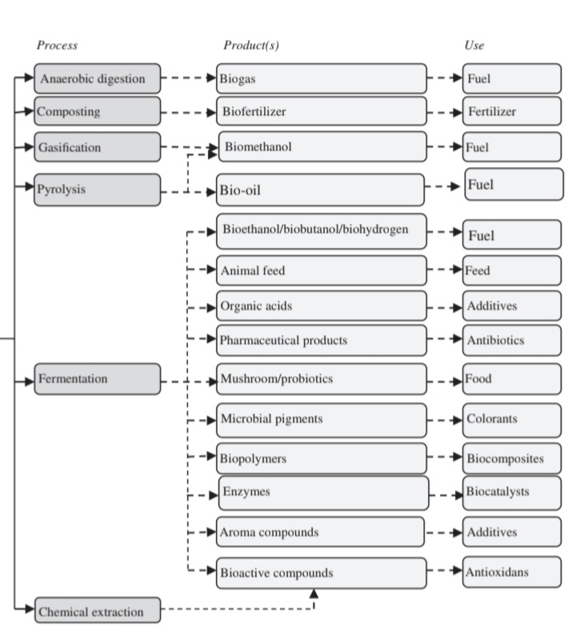

Figure 5 The biorefinery concept for valorization of crop residues [34].

**Chapter VI**

**Material and methods**

# Chapter 6 Material and methods

**Introduction**

This chapter outlines the experimental methodology, details the equipment and reagents utilized, and describes the characterization of the biocoagulant/bioadsorbent used, before and after decontamination process. The considered biomaterial is the residue resulting from supercritical extraction of onion seed (OSER: Onion Seed Extract Residue).

Supercritical extraction of oil from onion seed:

The potential benefits of onion seed oil are two-fold. It has traditionally been used for certain health purposes, but it also shows promise for hair and scalp health. Here's a closer look.

## Potential Health Benefits (limited research)

* **Anti-inflammatory properties:** Onion seed oil contains a compound called thymoquinone, which exhibits anti-inflammatory properties in studies. This might be beneficial for conditions like arthritis or asthma, although more research is needed.
* **Antioxidant activity:** The oil is rich in antioxidants, which can help protect the body from free radical damage and potentially reduce the risk of chronic diseases. However, strong clinical evidence is lacking.

Hair and Scalp Health (more promising research):

* **Hair growth:** Studies suggest that onion seed oil may stimulate hair growth. One study showed promising results for increasing hair density in people with alopecia areata (hair loss).
* **Antibacterial properties:** The oil may have some antibacterial properties that could help combat scalp issues like dandruff. However, more research is required to confirm this benefit.
* **Nourishing properties:** Rich in sulfur compounds, onion seed oil might help nourish and strengthen hair strands, potentially reducing breakage and promoting overall hair health.

## Residue of supercritical CO2 extraction of oil from onion seeds

The residue left behind after supercritical CO2 extraction of oil from onion seeds, namely as OSER, holds potential for valuable applications. We can valorize this residue by

### ****Extracting Valuable Compounds:****

* **Dietary Fiber:** The residue is likely rich in dietary fiber, a crucial component for gut health and digestive function. Techniques can be developed to isolate and purify this fiber for use in food products or nutritional supplements.
* **Antioxidant Compounds:** Onion seeds are known for their antioxidant properties. While some may be extracted with the oil, the residue might still contain valuable antioxidant compounds like flavonoids. These can be potentially extracted for use in the food or cosmetic industry.

### **Direct Use of the Residue:**

* **Animal Feed:** Depending on the composition and any pre-treatment steps, the residue could be a viable source of fiber and nutrients for animal feed. However, ensuring the absence of residual CO2 or other contaminants is essential.
* **Biocomposite Materials:** The fibrous nature of the residue makes it a potential candidate for use in biocomposites. These are eco-friendly materials made from combining natural fibers with a polymer matrix. SC-OSE residue could be used to create sustainable building materials, packaging materials, or even car parts.
* **Soil Amendment:** The residue can be composted or directly applied to soil as a source of organic matter. This can improve soil health, fertility, and moisture retention.

## ****Benefits of SC-OSE Residue Valorization:****

* **Reduced Waste:** By transforming the residue into valuable products, we significantly reduce waste generation from the supercritical extraction process.
* **Promotes Circular Economy:** Valorization aligns with the principles of a circular economy by maximizing resource use and minimizing waste.
* **Increased Sustainability:** Utilizing the residue for various applications promotes a more sustainable approach to onion seed oil production.

The potential for using residue from supercritical extraction of onion seed oil (OSER) as an adsorbent is an interesting and promising area of exploration. Overall, utilizing OSER as an adsorbent in water purification presents a novel approach for sustainable contaminant removal. However, substantial research is required to evaluate its feasibility and optimize its performance for specific application.

In this study we have studied the potential of OSER as biosorbent for removing a crystal violet and as biocoagulant to remove methyl green.

## Product and equipment used:

### Products

#### The residue resulting from supercritical extraction (OSER)

This residue is obtained under optimum supercritical onion seed extraction conditions (temperature pressure and CO2 flow). It is used as biocoagulant and biosorbent in coagulation-flocculation and sorption process respectively.

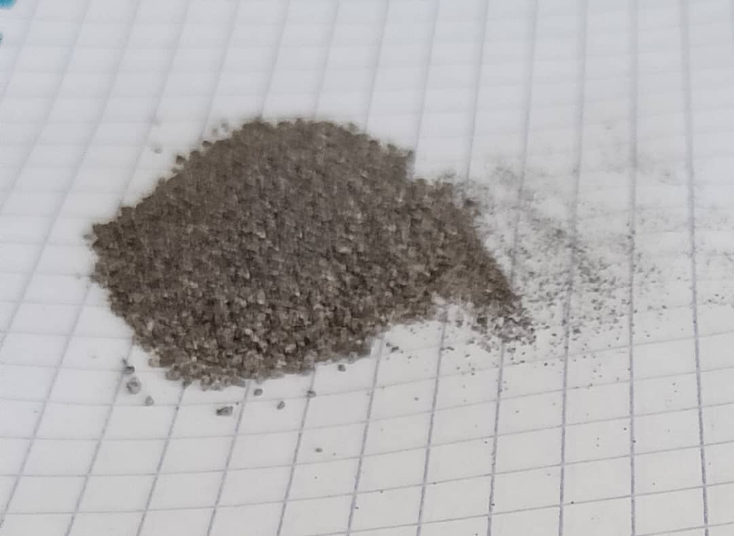

Figure 6 Powder of OSER

#### Crystal violet

Overall, crystal violet has found widespread use in various fields due to its ability to impart a distinct color and its affinity for binding to certain biological structures.

Crystal violet is widely used in microbiology for staining bacterial cells. It is a basic dye that binds to negatively charged components of bacterial cells, such as nucleic acids and certain proteins. This staining process is crucial for differentiating between Gram-positive and Gram-negative bacteria in Gram staining procedures.

In addition to its staining properties, crystal violet has antimicrobial properties. It disrupts bacterial cell membranes and inhibits cell wall synthesis. This antimicrobial activity has historically been utilized in antiseptic and disinfectant preparations, although its use for these purposes has declined due to concerns about toxicity and development of bacterial resistance.

crystal violet finds applications in other fields such as histology, where it is used for staining tissues and cellular structures. It is also employed in dyeing textiles and as an indicator in chemical assays.

Crystal violet, also known as gentian violet, has been shown to have potential endocrine-disrupting effects. Endocrine disruptors are chemicals that can interfere with the body's endocrine system, which is responsible for regulating hormones and other important functions. Studies have suggested that crystal violet may have estrogenic activity, meaning it can mimic the effects of estrogen in the body and potentially disrupt hormonal balance. While more research is needed to fully understand the extent of its endocrine-disrupting effects, caution should be taken when using products containing crystal violet, especially in sensitive populations such as pregnant women and children

##### Chemical Structure:

Crystal violet, also known as gentian violet or methyl violet, is a synthetic triarylmethane dye. Its chemical formula is C25H30ClN3, and its molecular weight is approximately 407.98 g/mol. The compound typically appears as dark green crystals or powder.

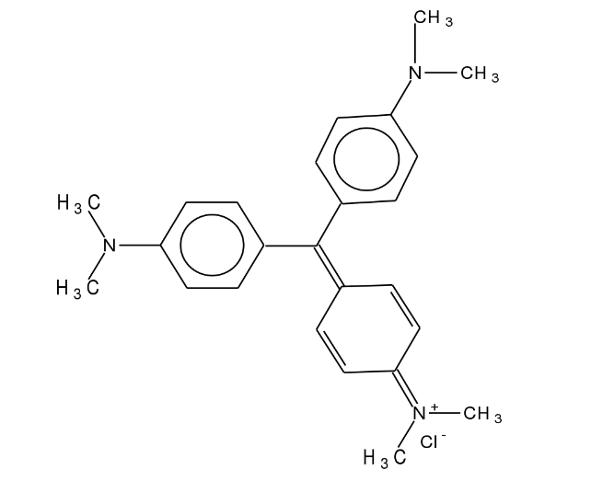

Figure 7 Crystal violet

Figure 8 Crystal violet calibration curve

#### Methyl green

Methyl green is a synthetic dye commonly used in histology and cytology for staining purposes.

It is known for its affinity to nucleic acids, particularly DNA. It binds strongly to chromatin and nucleoli in cell nuclei, making it an effective nuclear stain. It is widely used for staining sections of tissue samples to study the morphology and pathology of cells. Generally stable under normal laboratory conditions but should be stored in a dry, cool place, away from direct sunlight dissolved in water or ethanol.

##### Chemical Structure

Its chemical formula is C26H33Cl2N3 and its molecular weight is approximately 458.48 g/mol. The compound typically appears as green crystalline powder.

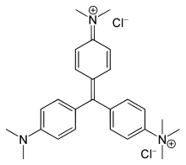

Figure 9 Methyl green

### Methyl Green Dye and its Impact

Methyl green is a broad term for a group of triarylmethane dyes, some of which are known to be harmful to the environment and human health. Here's a breakdown of its effects:

Impact on Water:

* **Reduced Light Penetration:** Methyl green, like many dyes, can significantly discolor water bodies, reducing light penetration. This disrupts photosynthesis for aquatic plants, the base of the food chain in most ecosystems.
* **Harm to Aquatic Life:** Reduced plant growth due to light blockage disrupts the food chain. Additionally, some methyl green variants might be directly toxic to fish, invertebrates, and other aquatic organisms.
* **Oxygen Depletion:** The breakdown of methyl green by microorganisms can increase Biochemical Oxygen Demand (BOD) in water. This means more oxygen is used by microbes, leaving less available for fish and other aquatic life.

Environmental Impact:

* **Persistence:** Many synthetic dyes, including some methyl green variants, are complex molecules that resist natural degradation. This means they can persist in the environment for long periods, continuing their harmful effects.
* **Wastewater Treatment Challenges:** Conventional wastewater treatment methods often struggle to remove dyes completely. This necessitates the development of more effective treatment solutions to prevent methyl green from reaching waterways.
* **Potential Toxicity on human health:** Methyl green can be irritating to the skin, eyes, and respiratory system upon contact or inhalation. Depending on the route and extent of exposure, it might cause more serious health problems.
* **Regulations:** Due to its potential hazards, regulations might exist governing the use and disposal of methyl green in certain regions. It's important to follow these guidelines to minimize human exposure.

While the specific effects of methyl green can vary depending on the type, it's generally considered a pollutant with negative consequences for the environment and potentially human health.

Figure 10 Methyl green calibration curve

### Materials

#### Thermometer

Water temperature is an essential parameter for user comfort and allows for the calibration of analysis parameters that are influenced by temperature. In-situ temperature measurement is necessary, and devices used for measuring conductivity or pH typically incorporate integrated thermometers for accurate assessment

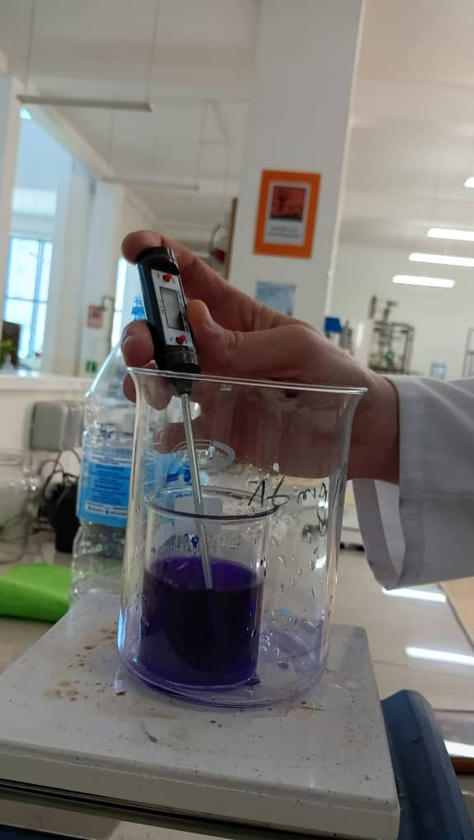

Figure 11 Thermometer

#### pH meter

A pH meter is an analytical instrument used to measure the acidity or alkalinity of a solution, among all the physiochemical parameters analyzed in the field, it is one of the most important factors influencing coagulation flocculation and also adsorption.

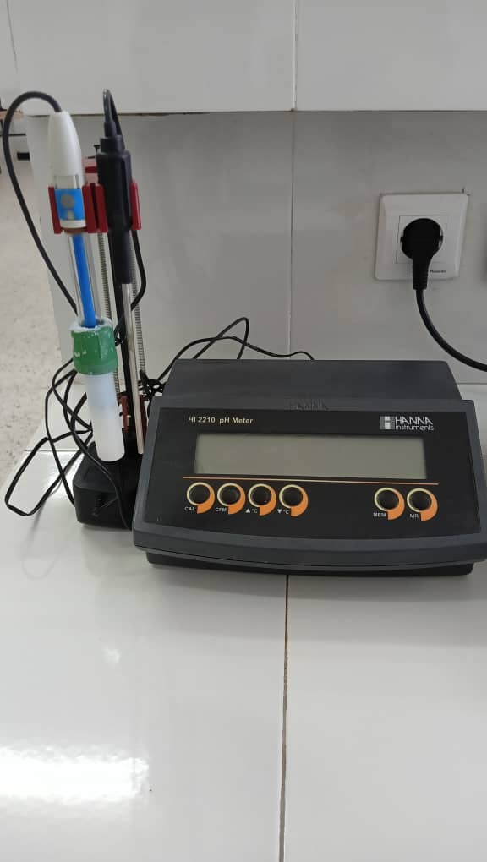

Figure 12 pH meter

#### Magnetic agitator

A magnetic agitator, also called a magnetic stirrer, is a laboratory device designed to stir liquids. It uses a rotating magnetic field to spin a magnetic stir bar placed in the liquid, thereby mixing it. This equipment is frequently used in chemistry and biology labs for mixing solutions or suspensions.

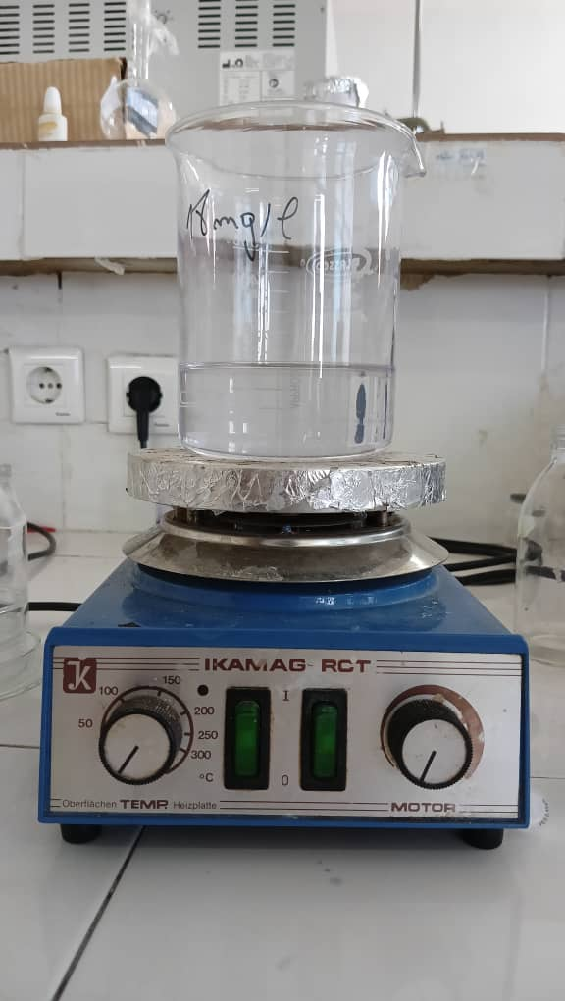

Figure 13 Magnetic agitator

#### Centrifuge

A centrifuge is a laboratory device that uses rapid spinning to separate substances of different densities. By applying centrifugal force, it can separate components based on their size, shape, density, or viscosity. This technique is widely used in various scientific and medical applications.

Components of a centrifuge:

* **Rotor:** The rotating component that holds the sample containers.
* **Sample containers:** Tubes or vials that hold the substances to be separated
* **Motor:** Drives the rotor to spin at high speeds
* **Control panel:** Allows the user to set the speed and duration of centrifugation

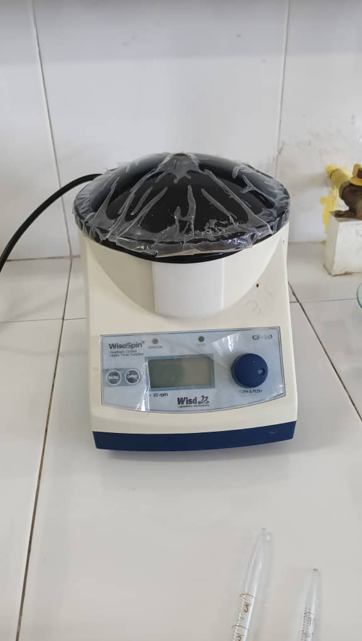

Figure 14 Centrifuge

#### Drying oven

A drying oven is a piece of equipment used to remove moisture from materials or products. This is commonly used in industrial processes, laboratories, and various production environments where controlling moisture content is essential.

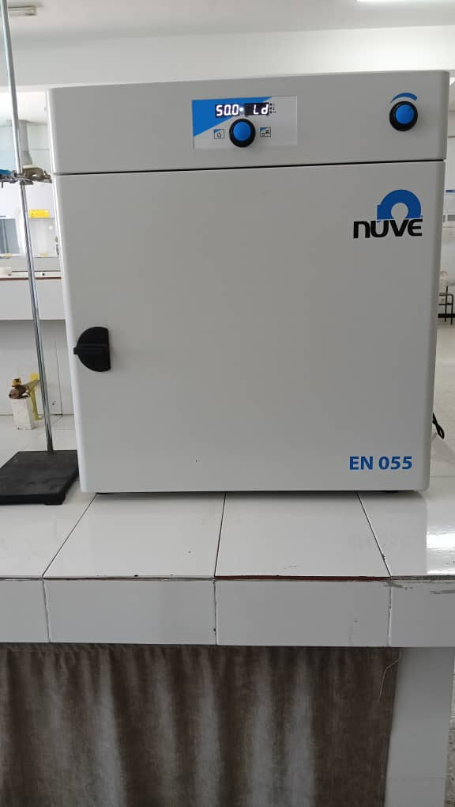

Figure 15 Drying oven

#### UV-Visible spectrometry

UV-Visible spectrometry analyzes how molecules interact with UV and visible light. By measuring the absorption or transmission of light at different wavelengths, it provides insights into a sample's structure, concentration, and chemical properties, it measures the absorbance of a sample in the ultraviolet and visible region of the electromagnetic spectrum (typically around 200-600 nm). It comprises four essential parts

* Light source
* Sample compartment
* Monochromator
* Detector

UV-Visible spectrometry operates based on two fundamental laws:

* **Beer-Lambert law:** this law states that the absorbance (A) of a sample is directly proportional to its concentration (C) and the path length (l) of the light through the sample, Mathematically, it is expressed as:

A= ε⋅c⋅l……(5)

A: absorbance

*ε* : is the molar absorptivity

C: is the concentration of the absorbing species

l: is the path length of the light through the sample

* **Second Beer-Lambert law:** This law states that the absorbance (A) of a sample is proportional to the intensity of the incident light (I₀) and the fraction of the light transmitted through the sample (I). Mathematically, it is expressed as:

A=−log (I/I0) ……(6)

A: absorbance

I: is the intensity of the light after passing through the sample

I0: is the intensity of the incident light

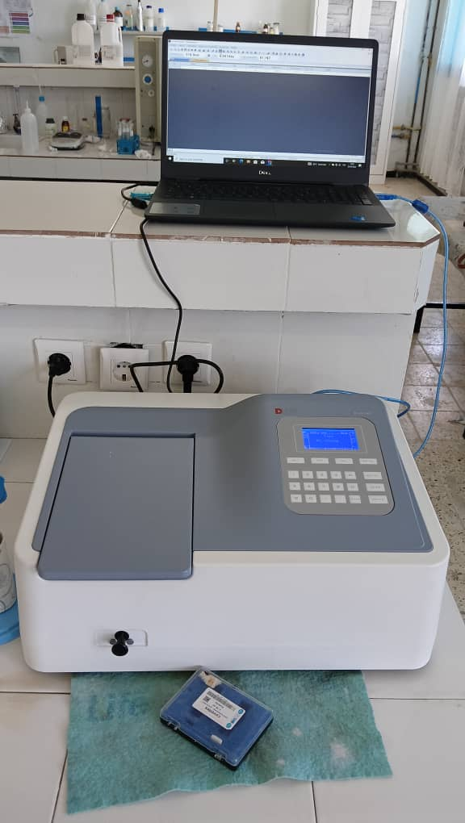

Figure 16 UV-Visible spectrometry

Using the coagulation-flocculation process with jar tests, determine the most effective treatment strategy for specific water sources to ensure efficient removal of organic and inorganic contaminants from industrial or municipal wastewater. Evaluate the effectiveness of various treatment chemicals in different water bodies.

#### Jar Test

Jar-test apparatus with stirrers and speed control

Beakers or jars

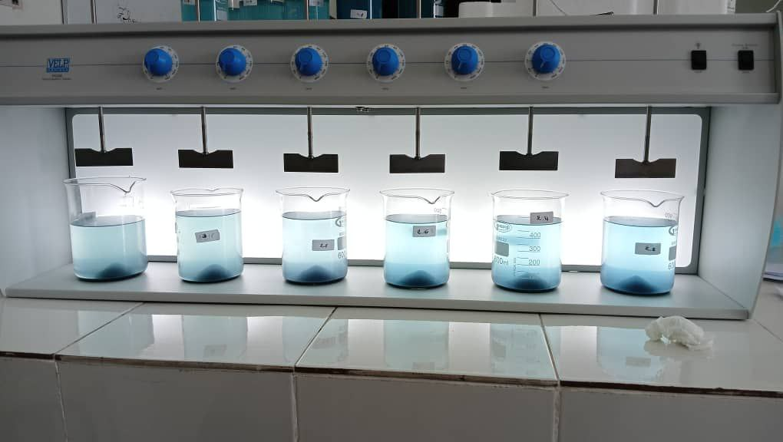

Figure 17 Jar test

#### The FTIR (Fourier Transform Infrared)

The FTIR (Fourier Transform Infrared) spectrometer is a Jasco FT/IR-4600. This type of instrument is used for obtaining an infrared spectrum of absorption, emission, photoconductivity, or Raman scattering of a solid, liquid, or gas sample.

**Caracteristics of the Jasco FT/IR-4600:**

* High sensitivity: The FT/IR-4600 is designed to provide high sensitivity and resolution, making it suitable for various applications, including material identification and quantitative analysis.
* Spectral range: It covers a broad spectral range, typically from 7800 cm⁻¹ to 350 cm⁻¹, which allows for the detection of a wide range of functional groups and molecular structures.
* Material Identification: Identifying unknown substances by comparing their spectral fingerprint to reference spectra.
* Quality Control: Ensuring the consistency and purity of products in industries like pharmaceuticals, polymers, and food.
* Environmental Analysis: Detecting pollutants and analyzing soil, water, and air samples.

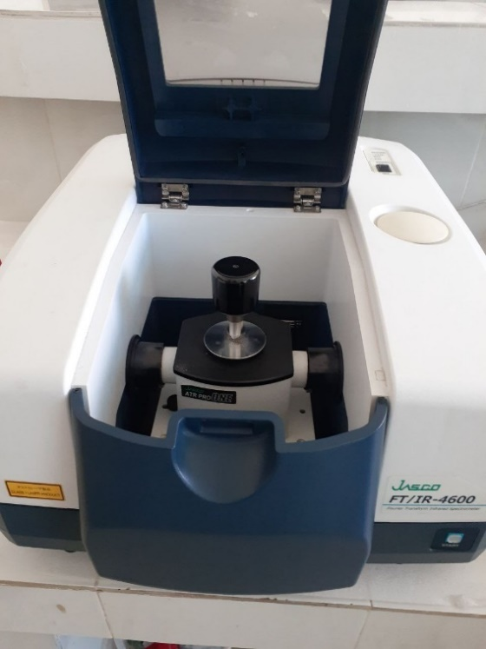

Figure 18 FTIR (Fourier Transform Infrared)

## Experimental procedures

### Adsorption procedure

* **Preparation of Adsorbent:**

-Dry the adsorbent material at 105°C for 24 hours to remove moisture.

-Weigh the required amount of adsorbent using an analytical balance.

* **Preparation of Adsorbate Solution:**

-Prepare a stock solution of the adsorbate at a known concentration.

-Dilute the stock solution to obtain various concentrations for the adsorption study.

* **Adsorption Experiment:**

-Add a fixed volume of adsorbate solution to a series of beakers.

-Adjust the pH of the solution if necessary, using a pH meter.

-Add a measured amount of adsorbent to each beaker.

-Place the beakers on a magnetic stirrer and stir at a constant speed for a specified contact time.

* **Analysis:**

-Measure the concentration of the adsorbate in the filtrate using a UV-Vis spectrophotometer.

#### Adsorption Capacity:

C0​: is the initial concentration,

Ce: is the equilibrium concentration,

V: is the volume of the solution,

m: is the mass of the adsorbent.

#### Adsorption Efficiency (R):

C0​: is the initial concentration,

Ce: is the equilibrium concentration

### Biocoagulation/Bioflocculation Experiment (Jar test)

A jar test is a common technique used to determine the optimal dosage of coagulant, flocculent, or other treatment chemicals for water treatment processes. Here's a protocol for conducting a jar test:

#### ****Preparation:****

-Record the initial temperature, pH, and concentration of Methyl green solution.

-Prepare a series of beakers or jars with equal volumes of the raw solution sample (typically 500 mL each).

#### ****Coagulant Dosage:****

-Select a range of coagulant dosages to be tested (0.1 mg/L to 3 mg/L).

-Add the desired amount of coagulant mass to each jar according to the chosen dosage range.

-Ensure proper mixing by starting the jar-test apparatus with a rapid stirring speed (120 rpm) for a specific time (4 minutes). This is the rapid mixing phase.

-Stop the stirring and allow for settling time (30 minutes).

#### ****Flocculent Dosage (Optional):****

-If using a flocculant, after the coagulant settling time, add a pre-determined dose of flocculant solution to each jar (same or varied doses can be tested).

-Briefly restart the jar-test apparatus at a slow mixing speed (30 rpm) for a short time (20 minutes) to promote floc growth.

-Stop the stirring and allow for additional settling time (30 minutes).

#### ****Evaluation:****

-After the settling time, observe the clarity of the supernatant (the liquid above the settled floc) in each jar. The jar with the clearest supernatant likely has the optimal coagulant and/or flocculant dosage.

-Measure the concentration of the supernatant in each jar using a UV. The jar with the lowest concentration reading indicates the most effective treatment.

-Consider factors like floc size, settling rate, and residual concentration when determining the optimal dosage.

#### ****Data Analysis:****

-Record your observations and measurements for each jar.

-Plot the data (coagulant/flocculant dosage vs. concentration) to identify the optimal dosage range.

## Characterization of Oil supercritical Extract Residue (OSER)

Characterization of our biomaterial (OSER) is essential to understand its functionalities, pH level, and retention capacities. This helps in understanding the phenomena at play. For this purpose, we considered the following parameters:

* Dosage of surface function by Boehm method
* pH at zero charge
* Iodine index
* Phenol index
* Methylene blue index
* Function groups by FTIR spectrum

### Identification and Dosage of Surface Functions Using the Boehm Method

The Boehm titration method is used to quantify the surface functional groups, by titrating with different bases and acids. The given concentrations in mmol/g can be analyzed to determine the amount of acidic and basic functional groups on the surface. The procedure followed is as below:

-Contact 1g of spec with solutions of Na₂CO₃, NaHCO₃, NaOH, and HCl, each at a concentration of 0.1M.

-Stir the solutions for 96 hours.

-Centrifuge the solutions after stirring.

-Titrate 10 ml of the filtrate from the basic solutions (NaOH or NaHCO₃) with HCl, using methyl orange as indicators. Likewise, titrate to determine the excess base or acid.

The method calculates the total acidity or alkalinity of a material by titrating acidic and basic surface groups. The number of these surface functional groups is then determined.

NaHCO₃ neutralizes carboxylic groups.

Na₂CO₃ neutralizes carboxylic and lactonic groups.

NaOH neutralizes carboxylic, lactonic, and phenolic groups.

The calculation method used to determine surface functionality varies based on the titration method employed. We used the volumetric titration method. After titration, the volume is noted and the number of functional groups is calculated using the following equation:

$functional group (mmol/g)=\frac{Vinitial}{Vf}×\frac{\left(C-V\right)titr}{M}$

**C titr:** consentration of the solution used for direct titration.

**𝑉 titr​:** Volume of the solution used for titration.

**𝑉f​:** Volume of the filtrate taken from the solution (10 ml).

**𝑉 initial**: Volume of the solution mixed with the solid (50 ml).

During the quantification of acidic and basic groups on the surface of our material, the results were as follows:

Table 2 Determination of Surface Functions

|  |  |
| --- | --- |
| Type of Function | Concentration (mmol/g) |
| Basic group | 0.1028 |
| Acidic group | 0.125 |
| Carboxylic group | 0.0535 |
| Phenolic group | 0.06839 |
| Lactonic group | 0.00311 |

The product has both acidic and basic character, with the total acidic groups (0.125mmol/g) slightly higher than the basic groups (0.1028mmol/g).

Phenolic Groups have the largest portion among the acidic groups, with 0.06839mmol/g.

The product exhibits a slightly more acidic character overall, with phenolic groups being the most prevalent functional group.

So, we can conclude that our biomaterial has a **slightly acidic character**.

### pH at the point of zero charge:

The point of zero charge (pzc) is an essential characteristic of adsorbents that significantly influences the adsorption percentage and varies among different materials. This parameter refers to the pH value at which the adsorbent's surface charge is neutral, resulting in minimal electrostatic attraction between the adsorbent and the charged species in the solution. The pHpzc is influenced by various factors, including the nature of the adsorbent surface, its chemical composition, and the surrounding electrolyte concentration.

* **Experimental procedure**

Solutions of $NaCl$ with a concentration of 0.1 N were prepared with varying pH values ranging from 2 to 12, which were adjusted using NaOH or HCl. The volume of each solution was 50 ml.

-The procedure involves the introduction of 0.1 g of OSER into each solution.

-The sample was subjected to continuous shaking for a period of 48 hours.

-The samples were passed through a syringe filter to remove impurities

-The final pH of the supernatant was measured in accordance with scientific protocol

-The ${pH}_{final} = f(pH_{initial}) or pH_{initial} = (pH_{final} -pH_{initial})$ plot can be utilized to determine the isoelectric point. The point of zero charge (${pH}_{pzc}$) can be determined by the point at which the pH final and pH initial values are equal.

The point of intersection between the curve and the x-axis, which passes through zero, represents the isoelectric point [10].

At a pH value lower than the point of zero charge $(pH_{pzc})$, the biomaterial surface acquires a net positive charge.

At pH above $pH_{pzc} (pH> pH_{pzc})$, the surface of biomaterial being negatively charged

The result is shown in the graph bellow

Table 3 pH zero charge

|  |  |  |  |  |  |  |
| --- | --- | --- | --- | --- | --- | --- |
| pH i | 2 | 4 | 6 | 8 | 10 | 12 |
| pH f – pH i | 1.2 | 1.8 | 0.39 | -1.82 | -3.68 | -1.25 |

Figure 19 pH zero charge of OSER

Table 3 and Figure 1 show the relationship between initial and final pH.

The point of zero charge is determined to be at pHPZC = 6.2

This value confirms a slightly acidic nature, obtained through the Boehm method for surface function titration (acidic function with 0.125mmol/g higher than basic functions with 0.1028mmol/g).

At **pH < 6.2**: ranging from 0 to 6.2 the surface of OSER will exhibit a positive charge and thus attract ions that are negatively charged, and tend to form complexes with negatively charged functional groups on the surface biomaterial.

At **pH > 6.2:** ranging from 6.2 to 12, the surface of OSER will exhibit a negative charge and will attract ions that are positively charged, and tend to form complexes with positively charged functional groups on the surface of our biomaterial.

### Iodine index

The quantity of mono iodide chloride, expressed in grams of iodine adsorbed per gram of OSER, the iodine index allows measuring its iodine content, two tests were conducted:

The first, a blank test, where 10 ml of a 0.1N iodine solution is placed in a beaker, and a 0.1N sodium thiosulfate solution is titrated, in the presence of a few drops of an indicator solution, until the color disappears.

The second test involves adding 0.2 g of OSER to a beaker containing 15 ml of a 0.1 N iodine solution, with agitation for 4 minutes. After centrifugation, 10 ml of the filtrate is titrated with a 0.1 N sodium thiosulfate solution, in the presence of two drops of starch solution.

The iodine index can be calculated using the following formula:

$$Id=\frac{\left(Vb-Vs\right) N×\left(126.9\right)(15/10)}{m}……(8)$$

$(Vb-Vs)$ is the difference in titration results between the blank test and the test with OSER (in ml) of 0.1N sodium thiosulfate.

**N:**is the normality of the sodium thiosulfate solution (N).

**126.9** is the atomic mass of iodine.

**m** is the mass of OSER (in g).

According to the calculation:

Id= 380.7 mg/g

Based on this result, we can say that our biomaterial has a high capacity for iodine adsorption, it can be concluded that the OSER has a highly microporous structure.

### Methylene blue index

The methylene blue index (mg/g) can be used to quantify the macrospores (2–5 nm) on the surface of an adsorbent. A considerable adsorption capacity for big molecules is indicated by this value. The volume, expressed in milliliters, of a standard methylene blue solution stained by one gram of material is known as the methylene blue index. Using UV-visible spectroscopy, the amount of methylene blue was measured.

At a wavelength of 664 nm, the methylene blue molecule's absorption spectrum has a highest peak in the visible area. The blue methylene index, or waste tire adsorption capability, can be calculated using the following formula, which is based on scientific literature.

The methylene blue (MB) index in mg/g quantities mesopores and macropores.

The MB index is calculated using the initial and residual concentration of MB.

The methylene blue index is calculated using the formula:

$$Q =\frac{(C₀-Ce)V}{m}……(9)$$

**C₀:** Initial concentration of methylene blue solution (50 mg/L)

**Ce:** Final concentration of methylene blue solution after adsorption

**V:** Volume of the methylene blue solution (50 mL)

**m:** Mass of the adsorbent (1 g)

Table 4 Results of methylene blue index

|  |  |  |  |  |  |  |  |  |  |
| --- | --- | --- | --- | --- | --- | --- | --- | --- | --- |
| t (min) | 5 | 10 | 15 | 20 | 30 | 45 | 60 | 90 | 120 |
| Cr (mg/l) | 7.69 | 5.33 | 4.59 | 3.66 | 3.61 | 3.43 | 3.52 | 2.17 | 2.68 |
| q mg/g | 2.76 | 2.88 | 2.92 | 2.96 | 2.97 | 2.98 | 2.97 | 3.04 | 3.01 |
| R% | 87.88 | 91.60 | 92.72 | 94.23 | 94.30 | 94.59 | 94.49 | 96.56 | 95.76 |

Table 3 presents the adsorption capacity of methylene blue over time, showing high retention with values around 2.98-3.04 mg/g and efficiency around 94-96 %.

**qe=3.04 mg/g**

The data shows high adsorption capacity and removal efficiency or methylene blue, indicating that the material being tested has significant mesoporosity and macroporosity.

The consistent values of retention (around 2.97 to 3.04 mg/g) and high removal efficiency (above 94%) across different time intervals indicate that the material is highly effective in adsorbing methylene blue from the solution.

Overall, the results suggest that the material has a strong capacity for methylene blue adsorption, confirming its high mesoporosity and macroporosity.

### Phenol index

Phenol index is used to evaluate the presence of mesopores in OSER using phenol as a model molecule.

1g of OSER is added to a 500 ml solution of phenol (200 mg/L) and stirred for 2 hours.

The solution is centrifuged, and the absorbance of the filtrate is measured.

The residual phenol concentration is determined Cr

Table 5 Results of Phenol index

|  |  |  |  |  |  |  |  |  |  |
| --- | --- | --- | --- | --- | --- | --- | --- | --- | --- |
| t (min) | 5 | 10 | 15 | 20 | 30 | 45 | 60 | 90 | 120 |
| Cr (mg/l) | 227.74 | 242.46 | 233.16 | 233.94 | 246.33 | 230.84 | 287.39 | 315.28 | 258.73 |
| Cr blank(mg/l) | 10.14 | 13.80 | 9.50 | 12.39 | 10.28 | 10.98 | 12.81 | 11.76 | 12.53 |

Based on the findings, it appears that our adsorbent isn't effectively removing phenol; rather, it seems to be increasing the phenol concentration. This indicates that our adsorbent does contain phenol.

## Results of FTIR characterization of OSER before and after treatment

The FTIR spectroscopy provides structural and compositional information on the functional groups presented in the sample. The functional groups present in the oil supercritical extract residue (OSER) were investigated by FTIR spectra within the range of 400-4000 cm-1 wave number. Figure 2 show the band positions in the FTIR spectra of the OSER before and after crystal violet adsorption and methyl green biocoagulation results presented in Table 5. The adsorption spectra displayed a number of adsorption peaks indicating the complex nature of OSER and it was composed of various functional groups which are responsible for the binding of considered pollutants.

The spectral data obtained for OSER before and after adsorption and coagulation are depicted in the figures presented below:



Figure 20 FTIR Spectrum of OSER before and after adsorption and coagulation

Table 6 FTIR results of OSER before and after adsorption and coagulation

|  |  |  |  |  |
| --- | --- | --- | --- | --- |
| Wavenumber (cm-1) | OSER | OSER (MG) | OSER (CV) | Functional group |
| 3262 | + | + | + | hydroxyl groups O-H |
| 2921 | + | + | + | alkanes C-H |
| 2851 | + | + | + | alkanes C-H |
| 1744 | - | + | + | esters, ketones, or carboxylic acids  carbonyl groups (C=O) |
| 1641 | + | + | + | alkenes C=C |
| 1541 | + | + | + | amines and amides N-H, C-N |
| 1359 | + | - | - | amines and amides N-H, C-N |
| 1367 | - | + | - | amines and amides N-H, C-N |
| 1238 | + | + | + | alcohols, ethers, esters, and carboxylic acids |
| 1152 | - | + | - | alcohols, ethers, esters, and carboxylic acids |
| 1041 | + | - | - | alcohols, ethers, esters, carboxylic acids C-O |
| 1021 | - | + | + | alcohols, ethers, esters, carboxylic acids C-O |

The FTIR (Fourier Transform Infrared) spectra provided show the infrared absorption characteristics of three different samples: onion powder, onion powder loaded with CV (presumably crystal violet), and onion powder loaded with MG (methylene green). To interpret these spectra and identify the functional groups present in each sample, we can refer to the characteristic absorption bands commonly observed in infrared spectroscopy.

* O-H Stretching (Broad, 3200-3600 cm⁻¹)

A broad band around 3262 cm⁻¹ indicates the presence of O-H stretching vibrations, typical of hydroxyl groups found in alcohols, phenols, or carboxylic acids.

* C-H Stretching (2850-2950 cm⁻¹)

The peaks near 2921 cm⁻¹ and 2851 cm⁻¹ are associated with C-H stretching vibrations in alkanes, which can be seen in all three samples.

* Carbonyl (C=O) Stretching (1650-1750 cm⁻¹)

A strong peak at 1744 cm⁻¹ indicates the presence of carbonyl groups (C=O), typical for esters, ketones, or carboxylic acids.

* C=C Stretching (1600-1680 cm⁻¹)

The peak around 1641 cm⁻¹ suggests the presence of C=C stretching, indicative of alkenes.

* N-H Bending and C-N Stretching (1000-1500 cm⁻¹)

Peaks around 1541 cm⁻¹ and 1367 cm⁻¹ in might indicate N-H bending and C-N stretching vibrations, common in amines and amides.

* C-O Stretching (1000-1300 cm⁻¹)

Peaks at 1122 cm⁻¹, 1041 cm⁻¹, and 1021 cm⁻¹ can be attributed to C-O stretching vibrations, which are common in alcohols, ethers, esters, and carboxylic acids.

The FTIR spectra provide information on the functional groups present in the samples. The OSER loaded with CV and MG shows distinct peaks corresponding to various functional groups, such as O-H, C-H, C=O, C=C, and C-O, indicating the complex composition of these samples and the changes due to loading with CV and MG.

**Chapter VII**

**Results and discussion**

# Chapter 7 Results and discussion

**Part 1: Biocoagulation**

**Introduction**

In this section, we explore the potential of utilizing of OSER as a biocoagulant and evaluate its efficacy in reducing the concentration of methyl green dye (MG) in synthetic aqueous solutions. This experiment aims to determine the optimal dosages of the biocoagulant OSER by employing varying amounts, ranging from 0.1 to 3.2 g, and flocculants such as clay and an industrial polymer, with masses ranging from 2 to 300 mg. We investigate also the influence of pH on these processes. By preparing aqueous solutions of methyl green dye with different dosages of coagulants and flocculants, and adjusting the pH to values between 2.3 and 11.8 using hydrochloric acid (0.1M) or sodium hydroxide (0.1M), we aim to observe the formation and settling of flocs. The efficiency of particle removal will be assessed using UV-visible spectrometry, which provides absorbance values that are utilized to determine concentration via a calibration curve. This experiment hypothesizes that there exists an optimal dosage range for both coagulants and flocculants, and that the effectiveness of these processes is significantly influenced by the pH of the sample.

## Effect of dosage of OSER

The biocoagulant dosage was systematically varied from 0.1 up to 3.2 g/l for an aqueous solution of MG with 10 mg/L of concentration, a temperature of 22°C a pH of 5.9. The conductivity of the sample was 61.7 µs. The results obtained are represented in the figure below.

Figure 21 Effect of OSER dosage on the concentration

Figure 22 Effect of OSER dosage on the yield

Based on the data presented in the two previous figures, it is evident that the optimal biocoagulant dosage appear to be around 2 g/L, it reduced the concentration of the dye (methyl green) from 10 mg/L to 2.79 mg/L which represents a yield of **72.03%,** beyond this dose additional benefits are obtained yet are almost negligible, and there will be an increase in residual levels, indicating overdosing, the excessive coagulant dosage leads to the restabilization of the ions of the dye, resulting in water with high coagulant content and poor clarification, explaining why the UV results keep rising, these finding confirm that the optimal coagulant dosage is 2 g.

## Effect of flocculent

In order to improve the efficiency of removal of MG by increasing the volume and the density of flocs, we have tested two flocculants namely clay and industrial flocculent.

The flocculent dosage was systematically varied from 2 mg up to 300 mg in 500 ml for an aqueous solution with a temperature of 22°C, a pH of 5.9 and a conductivity of 68.9 µs, initial concentration of 10 mg/L and 2 g of biocoagulant as optimal dose. The results of the biocoagulation-bioflocculation process are shown in the following figures.

Combine the curves of the initial concentration (two flocculants) and the efficiency (both flocculants).

Figure 23 Effect of clay dosage and industrial polymer dosage on yield

Figure 24 Yield of OSER and Different Flocculants

Figure 25 Concentration initial and concentration rested of using OSER and Different Flocculants

Based on the data presented in the previous figures, it is evident that the optimal flocculent dosage appears to be around 5 mg for clay and 20 mg for commercial flocculent. This dosage reduces the concentration of green methyl dye from 10 mg/L to between 2.91 mg/L and 2.96 mg/L, representing a yield of nearly 70%. However, the yield achieved by using coagulation alone is 72%. This comparison indicates that flocculation does not provide any additional effect beyond what coagulation alone can achieve.

According to the graph, above a certain value, the presence of flocculent has a negative effect on yield, since the excess flocculent molecules generate a high level of kinetic energy, which helps to restabilize the molecules and create a high molecular density that prevents molecules from sticking together.

## Effect of pH

The pH was systematically adjusted between 2.3 to 11.8 for an optimal coagulant dosage of 2 g/L at 21°C with a conductivity of 66.4 µS, initial concentration of 10 mg/L.

The results of the coagulation with the adjusted pH are well represented in the following figures:

Figure 26 Effect of pH on the yield

Figure 27 Effect of pH on concentration

The effectiveness of coagulation is significantly influenced by pH, as it affects the solubility and charge of both the coagulant molecules and the particles being removed. In this study, it was observed that within a pH range of 4 to 9.8, there was a clear increase in yields and a substantial decrease in dye concentration. A pH of 10 was identified as optimal, yielding the best results with a removal efficiency of 80% and the most effective removal of green methyl particles from the aqueous solution.

In contrast, at the extreme pH values of 2 and 11.8, the results were the poorest in terms of residual concentration and yield. These pH levels likely result in the coagulant molecules being either excessively protonated or deprotonated, reducing their effectiveness in neutralizing the charges on the dye particles and forming flocs.

This study underscores the importance of maintaining an optimal pH range during coagulation processes to maximize efficiency in dye removal from aqueous solutions. Adjusting the pH to an optimal level significantly enhances the performance of the coagulation process, leading to improved water quality and more effective treatment outcomes.

The hypothesis that coagulation is based on electrostatic phenomena cannot be excluded. At low pH, methyl green is protonated and positively charged; at this pH, our OSER biomaterial is also positively charged, inducing electrostatic repulsion. As the pH increases, the cationic character of the dye decreases and the biocoagulant also loses its acidity, promoting electrostatic attraction between the dye and the biocoagulant. At basic pH levels, the overall surface of the OSER is negatively charged, which reduces attraction and thus coagulation efficiency.

**Part 2: Biosorption study**

**Introduction**

In order to valorize the residue of onion seed oil extraction and exploring its potential in water treatment, we tested them as biosorbents and biocoagulants for the reduction of crystal violet and methyl green present in aqueous solutions respectively.

## Adsorption study

In order to study the retention of crystal violet (CV) by bisorption on by product of supercritical oil extraction of onion seed (OSER), the experimental work plan followed was:

Study of the influence of different physio-chemical parameters, such mass of biosorbent, the contact time, initial concentration of CV, pH of the solution, and the temperature.

Determination of kinetic model of biosorption of CV

Determination of biosorption isotherm model of CV

### Effect of dosage

To investigate the impact of the solid/liquid ratio on crystal violet retention using OSER, various masses of this biomaterial were tested while keeping the solution volume constant. All other experimental conditions were maintained consistently throughout the study. The results obtained are shown in figure below.

Figure 28 Effect of dosage of OSER on the capacity

Figure 29 Effect of dosage of OSER on the yield

**Condition :** C0 = 50 mg, V = 50 ml, pH = 5.5, T = 22°C

The dosage of an adsorbent is crucial because it directly affects the efficiency of the adsorption process. Using the correct amount ensures optimal removal of contaminants or target molecules. The fig shows that the percentage removal of crystal violet molecules exhibits a gradual increase with rising adsorbent dosage from 0.05g/50 ml to 2g/50 ml. Subsequently, the removal percentage stabilizes with further increase in adsorbent dosage, ranging from 1g/50 ml to 2g/50 ml.

Increasing the amount of OSER, from 0.5g to 2g, used in the adsorption process led to a higher percentage of crystal violet removal from the solution. This is because the larger masses of OSER provides more surface area and porosity, allowing it to adsorb a greater number of crystal violet molecules and reduce their concentration in the solution.

At t= 30 minute and with m= 1g the equilibrium, 98.79% of the crystal violet molecules have been removed from the solution, it can thus be inferred that the affinity of crystal violet with the OSER biosorbent is most pronounced during the initial stages.

Figure 30 Retention capacity with different masses utilized

### Influence of contact time

The duration of contact significantly influences the retention of various contaminants, determining the point of adsorption equilibrium and its characteristics is essential to identifying the distinct point of the isotherm. Moreover, since adsorption involves transferring pollutants from a liquid phase to a solid phase, the time of contact between these phases is critical limiting factor.

In order to determine the optimal contact time, we’ll launch an experiment and take samples every well determined period of time, the experiment will last for 120 minutes (2 hours), We considered 8 time variation namely 5 15 30 60 75 90 105 120 minutes with the naturel pH of 5.5, concentration of 50 Mg/L, volume of crystal violet solution 50 ml, and a mass of the OSER biosorbent of 1g.

The system is subjected to moderate agitation, and the variations in the liquid concentration are observed over time.

Figure 31 Effect of contact time on the capacity

Figure 32 Effect of contact time on the yield

**Condition** : C0 = 50 mg/L, V= 50 ml, pH= 5.5, m=1g, T= 22°C

The removal efficiency of crystal violet exhibited a rapid initial phase, achieving equilibrium within 60 minutes of contact, after which it remained nearly constant for the remainder of the experiment, this swift initial adsorption of the crystal violet molecules can be attributed to the concentration gradient between the solution and the unoccupied active sites on the biosorbent, the gradual increase in adsorption, leading to equilibrium is likely due to the limited mass transfer of adsorbate molecules from the bulk liquid to the adsorbent external surface. At equilibrium, 97.348% of crystal violet was removed from the solution after 60 minutes with a maximal capacity of qe= 1.04mg/g.

## Kinetic study

Kinetic studies in adsorption are essential for understanding the rate at which adsorbate molecules adhere to the surface of an adsorbent. To identify the most suitable model for describing the crystal violet biosorption kinetics of the newly developed OSER biosorbent, the commonly employed kinetics models namely the pseudo-first-order model, the pseudo-second-order model, and the intraparticle diffusion model were thoroughly examined.

### Pseudo-first-order kinetic

The pseudo-first-order kinetic model is frequently employed to characterize adsorption kinetics. This model posits that the rate of site occupation during adsorption is directly proportional to the number of available, unoccupied sites. It is predominantly applicable to systems where the adsorption process is governed by physical adsorption, or physisorption.

Lagergren’s rate equation is among the most extensively utilized rate equations for describing the adsorption of an adsorbate from the liquid phase, the linear form of the pseudo-first-order equation is expressed as follows:

$Ln (qe​-qt)=ln (qe) – k₁​t$ ​……(10)

Where qe and qt (mg/g) are the amounts of crystal violet molecules adsorbed onto the OSER biosorbent at equilibrium and at time t (min).

By plotting ln(qe-qt) versus time, the pseudo-first-order kinetic constant k1 (min-1) and the equilibrium adsorption capacity qe (mg/g) can be derived from the slope and intercept of the resulting linear plot, respectively.

Figure 33 The pseudo-first-order kinetic model of biosorption of crystal violet on OSER

It is clear that the kinetic model was not suitable for describing the biosorption model, it did not yield satisfactory results, specifically, the model showed a poor fit to the experimental Data, as indicated by a low coefficient of determination R2, since the difference values of the coefficient of determination R2 rage between 0.0368 and 0.2195.

### The pseudo-second-order kinetics

The pseudo-second-order kinetic model is frequently employed to characterize the adsorption process of solutes from a liquid phase onto a solid surface. This model posits that the rate-limiting step may involve chemisorption, which entails valence forces through the sharing or exchange of electrons between the adsorbent and the adsorbate, its expression is as follows:

$$dqt/dt =k₂{(qe​-qt​)}^{2}……(11)$$

Where:

**qt:** the amount of the solute adsorbed at time t (mg/g)

**qe:** the amount of the solute adsorbed at equilibrium (mg/g)

**k2:** the pseudo-second-order rate constant (g/mg/min)

By integrating the rate equation with the boundary conditions qt = 0 at t = 0 and qt = qt at

t = t

We get:

**2**……(12)

By plotting t/qt versus t yields a straight line with a slope of 1/qe and intercept of 1/k2qe2 obtained values of k2 and qe were used to evaluate the initial adsorption rate (h) which is given as:

$h=k2{qe}^{2}$……(13)

Figure 34 The pseudo-second-order kinetic model of biosorption of crystal violet

The preceding equation enables us to determine the parameters of the kinetic model (qe and k2) for each concentration studied, and the results obtained are grouped together in the table below.

Table 7 Constants of the pseudo-first-order kinetic model

|  |  |  |  |  |  |
| --- | --- | --- | --- | --- | --- |
| C0(mg/L) | Pseudo-second-order | | | | |
| R2 | qexp (mg/g) | qe (mg/g) | k2 (g/mg.min) | h (mg/g.min) |
| 10 | 0,9999 | 0,21613 | 0,217 | 10,61 | 0,4956 |
| 30 | 0.9999 | 0,708519 | 0,709 | 8,113 | 4,0727 |
| 50 | 1 | 1,235803 | 1,2363 | 18,224 | 27,83 |
| 80 | 1 | 1,939834 | 1,944 | 3,180 | 11,96 |
| 100 | 0,9981 | 2,383952 | 2,388 | 1,454 | 32,926 |
| 200 | 1 | 4,758692 | 4,76 | 0,868 | 19,655 |

The satisfactory fitting of the experimental kinetic data to the second-order model was observed. For all initial concentration, the experimentally determined maximum adsorbed amount aligns very closely with the value calculated using the second-order kinetic model, additionally the high correlation coefficient R2 = 1 indicates a strong agreement between the model and the adsorption process, demonstrating the model’s suitability for describing the kinetic of this system.

High R2 values in adsorption studies indicates that the kinetic model provides an excellent fit to the experimental data, in our study the values consistently exceeded 0.9 across various concentrations, this indicates that chemisorption is the rate-limiting step in the crystal violet adsorption process on OSER biomaterial. For example, for initial concentration of mg/L

**R2= 1,** and the equilibrium experimental capacity **qexp= 1.235 mg/g** coincide very well with the equilibrium calculated capacity **qcal= 1.236** **mg/g**.

The chemisorption process likely involves electrostatic interactions between the negatively charged of OSER and the positively charged crystal violet ions. This indicates that the retention of crystal violet onto OSER is primarily driven by the formation of chemical bounds between the adsorbate (crystal violet) and the adsorbent surface (OSER). As a result, the rate of crystal violet biosorption onto OSER is dependent on both the concentration of the dye in the solution and the number of available sites on the OSER surface. Thus, chemisorption is identified as the predominant mechanism regulating crystal violet biosorption onto OSER.

## Intraparticle diffusion model

The intraparticle diffusion model is frequently employed in adsorption studies to elucidate the kinetics of the adsorption process, with a particular emphasis on the diffusion of adsorbate molecules within the pores of adsorbent particles. This model facilitates the comprehension of the mechanisms and rate-limiting steps inherent in adsorption processes.

The Weber and Morris equation, representing the intraparticle diffusion model, is typically expressed as:

$$qt=kd\sqrt{t}+C……(14)$$

Where:

**qt:** is the amount of adsorbate adsorbed at time t (mg/g min1/2)

**kd:** the intraparticle diffusion rate constant

**t:** the time

**C:** constant representing the intercept or initial adsorption

The parameter C correlates with the boundary layer thickness, while the slope represents the rate constant kd pertaining to intraparticle diffusion, that can be calculated from the slope of the linear plot of qt versus √t.

Figure 35 Intraparticle diffusion

The intraparticle diffusion model, as elucidated by Weber and Morris, outlines the kinetics of solute adsorption onto solid adsorbents, the model assumes that intraparticle diffusion is the primary rate-controlling step in the adsorption process. It postulates that the solute molecules initially adhere to the exterior surface of the adsorbent particles, then diffuse into the interior of the particles where further adsorption occurs, Interpreting the model, we understand that the rate of intraparticle diffusion, represented by the rate constant kd, influences the rate of adsorption. The model suggests that as time increases, more solute molecules diffuse into the particles, leading to increased adsorption until equilibrium is reached, the model's limitations stem from its assumption that intraparticle diffusion exclusively governs the rate of adsorption, overlooking the potential influences of external mass transfer resistance and surface reactions, experimental validation entails conducting adsorption experiments under controlled conditions and graphing the quantity of solute adsorbed versus the square root of time. If the experimental findings conform to the linear pattern anticipated by the model, it substantiates the involvement of intraparticle diffusion in the adsorption phenomenon.

Figure 36 The intraparticle diffusion on different phases

Table 8 Constant of intraparticle kinetic model

|  |  |  |  |
| --- | --- | --- | --- |
| t (min) | kd | C | R2 |
| (0,1,2,3) | 0,0072 | 2,4391 | 0,9852 |
| (4,5,10,20) | 0,0044 | 2,4475 | 0,9511 |
| (30,45,60) | 0,0015 | 2,4601 | 0,999 |

As can be seen from **Fig. (36)** for initial concentration 50 mg/L the adsorption was controlled by three different stages because the plots consist of three linear sections with different slopes. This demonstrates that the three stages are taking place.

The first stage is due to the external surface adsorption which is associated with the diffusion of the boundary layer [41]. The second stage is slower than the first, which is due to the diffusion of intra-particle. The third stage involves the final equilibrium stage for which the intra-particle diffusion starts to slow down due to the extremely low adsorbate concentration remaining in the solution [42]. It can be suggest that during the adsorption process, Crystal violet may be initially transported to the macro, mesopores, and then, finally, slowly diffused into the micropores. Similar results were also reported by Kumar et al. (2007) [43]. An increase in initial concentration produced a higher concentration gradient, which eventually caused the adsorption and diffusion process to become faster[44].

Table (8) represents the kd which express the diffusion rates of the different phases in the adsorption process. The rate of adsorption is in the order kd1 > kd2. The first steep sloped period is the instant diffusion stage (kd1= 0.72 (mg/g min1/2)). The adsorbent quickly adsorbed a large amount of Crystal violet. Because of the accumulation of CV biosorbed by OSER, the concentration gradients decrease, leading to the later stage decrease in biosorption rate. Then the resistance of diffusion increased, leading to decrease of the diffusion rate (kd2= 0.44 (mg/g min1/2)). The diffusion rate slowed down gradually and at last reached the equilibrium stage.

The plot deviates from the origin point, which means that intraparticle diffusion is involved in the process of biosorption, but is not the only rate controlling step.

The adsorption process may also involve some other mechanisms along with the intraparticle diffusion. Therefore, it appears that the system under consideration is more appropriately described by the pseudo second-order model, based on the assumption that the rate-limiting step may be chemical sorption or chemisorption involving valence forces through sharing or exchange of electrons between the biosorbent and the adsorbate with intraparticle diffusion mechanism involve as one of the rate-determining steps [45].

The diffusion coefficient D is derived from the following formula:

t1/2 = 0.03 r02/D

Where:

* t1/2: the half-reaction time (adsorption reaction at equilibrium) in seconds (t1/2 = 30 min)
* r02: the diameter of the adsorbent grains in centimeters (<0.350 µm)
* D : the intraparticle diffusion coefficient (cm2/s)

If the values of Di are in the range of 10−5 to 10−13 cm2/s then intraparticle diffusion is involved as the rate-limiting step, especially for chemisorption systems[46] [47]

For t1/2 = 30 min and r02 = 0.355 µm

D = 2.041 × 10-13 cm2/s.

The value of the pore diffusion coefficient D= 2.041 × 10-13 cm2/s is in the range of 10−6 to 10−8 cm2 /s, indicating that intraparticle diffusion was involved in the adsorption process controlled by chemisorption.

## Effect of initial pH

The effect of pH on adsorption was studied across different pH levels (ranging from 2 to 12) by adjusting the solutions to the desired pH values using appropriate reagents. Throughout the experiments, the initial concentration was kept constant at 50 mg/L, with 1 g of the residue of the supercritical extraction oil of onion seed and at contact time of 60 minutes. The obtained results are shown in the figures below.

Figure 37 Effect of initial pH on the adsorption capacity of CV by OSER

Figure 38 Effect of initial pH on the yield of biosorption of CV by OSER

As we can observe from the adsorption capacity change, the adsorption capacity reaches its maximum value qe= 2.1994 mg/g, at the pH= 6, with a slight decrease from pH=7 to 10, and a decrease from pH 10 to 12.

Figure 39 The different initial pH with the equivalent qe

The figure shows that increasing the pH of the medium causes a slight increase in the amount of Cristal violet adsorbed. The best maximum adsorption capacity is found at pH = 6.1. This increase in adsorption capacity can be explained by the increase in negatively-charged sites on the surface of our biomaterial (OSER) due to the loss of H+ (COO-, H+) from this surface to the medium, allowing the adsorption of other cationic dye molecules on these sites.

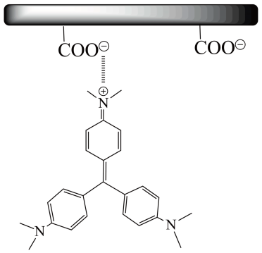

Figure 40 Zwitterionic Form of crystal violet

This could be the case for a couple reasons:

Surface Charge of Biomaterial: The surface charge of the biomaterial changes with pH. Depending on pHpzc = 6.2 of our biosorbent OSER, at certain pH levels, the surface charge of the biomaterial is optimal for attracting and binding the dye molecules. At pH 2, 4, 6, and 7, the surface charge might be such that it maximizes the electrostatic interactions between the dye molecules and the biomaterial, leading to high adsorption efficiency.

Ionization State of Dye: The ionization state of the dye can change with pH. Dyes can exist in different ionic forms depending on the pH of the solution. At pH 2, 4, 6, and 7, the dye molecules might be in a form that has a high affinity for the biomaterial. However, at pH 12, the dye might ionize in a way that reduces its affinity for the biomaterial, leading to lower adsorption.

Competition with Hydroxide Ions: At pH 12, the concentration of hydroxide ions (OH⁻) is very high. These hydroxide ions can compete with the dye molecules for adsorption sites on the biomaterial. This competition can reduce the number of available sites for the dye molecules, resulting in a slight decrease in adsorption efficiency.

Potential Biomaterial Degradation: High pH levels can cause some biomaterials to degrade or alter their structure. If the biomaterial starts to degrade or undergo changes at pH 12, its adsorption capacity might decrease, leading to a reduction in yield.

In summary, the high adsorption efficiency at pH 2, 4, 6, and 7 is likely due to optimal surface charge interactions and the favorable ionization state of the dye. At pH 12, competition with hydroxide ions and potential degradation of the biomaterial can slightly decrease the adsorption efficiency.

## Effect of initial concentration

The pollutant's adsorption capacity on the solid support is significantly influenced by its initial concentration. To examine this effect, we explored the impact of various concentrations, ranging from 10mg/l to 200mg/l.

Figure 41 Effect of initial concentration on the adsorption capacity

Figure 42 Effect of initial concentration on the yield of the adsorption by OSER

Figure 43 The different initial concentrations with the equivalent qe

This graph illustrates that as the initial concentration of metal increases from 10 mg/L to 200 mg/L, the adsorption capacity rises and then stabilizes after reaching equilibrium time. This trend can be attributed to the enhanced electrostatic interactions between the colorant ions and the active absorption sites. Additionally, as the colorant concentration increases, more adsorption sites are covered. The higher initial concentration also increases the affinity of the colorant ions for the active sites, providing a significant driving force to overcome mass transfer resistance between the aqueous and solid phases. It’s worth noting that the removal efficiency reaches a maximum of 84% for the case of concentration 10mg/l, but it reaches values between 97% and 99% for concentrations from 50 up to 200 mg/l.

## Effect of temperature

The effect of temperature on adsorption is a fundamental aspect that influences both the efficiency and mechanisms of adsorption processes, the study examined the adsorption of crystal violet at temperatures varying from 10°C up to 33°C with a constant initial concentration of 50mg/L, we used 1g of OSER and maintained a contact time of 60 min. The results obtained are shown in figures below.

Figure 44 Effect of temperature on biosorption of CV by OSER.

**Conditions:** C0 = 50 mg/L, V = 50 ml, pH = 5,5, m = 1g

Figure 45 The different temperatures with the equivalent qe

The study revealed that the adsorption of crystal violet was not significantly influenced by temperature variations within the range of 10°C to 33°C, the energy barriers associated with the adsorption sites on the OSER remain relatively unaffected by temperature changes, leading to a consistent adsorption capacity across the tested temperature range.

## Isotherm study

Adsorption isotherms graphically depict the relationship between the concentration of an adsorbate and the quantity that is adsorbed to the solid phase at a constant temperature and equilibrium pressure**.** The type of isotherm refers to the shape of the curve generated by the adsorption isotherm, which can vary based on the properties of the adsorbent and adsorbate. Different types of isotherms may be observed depending on the specific conditions and adsorbent used. Some examples include the S-type, L-type, H-type, and C-type isotherms. The isotherm from this study is shown in the figure below.

Figure 46 Isotherm biosorption of CV on OSER

### Langmuir isotherm

The Langmuir isotherm is a model used for systems with low concentrations or low-pressure gases, where the attraction between molecules adsorbed on the adsorbent and the non-adsorbed analyte decreases as they move away from the adsorbent surface. This isotherm is defined by equations where qe​represents the equilibrium amount of solute adsorbed per unit mass of adsorbent, Ce​ represents the equilibrium concentration of solute, qm​ represents the adsorption capacity of the monolayer, and kL​ is the Langmuir constant.

$$q_{e}=\frac{q_{m}KC_{e}}{1+kC_{e}}……(16)$$

The equation can be written in the linear form with $k_{d}=\frac{C_{e}}{q_{e}}$ $……(17)$

$$\frac{q_{e}}{C_{e}}=q_{m}k_{L}-k_{L}q_{e} ……(18)$$ and other linear forms can be derived by taking the inverse of the previous equation to get linear form.

$$\frac{1}{q_{e}}=\frac{1}{q_{m}k_{L}}\left(\frac{1}{C_{e}}\right)+\frac{1}{q_{m}} ……(19)$$

The values of qm​ and kL​ can be determined from the slope and intercepts of the plot of the linear forms of the Langmuir equation. One of the fundamental features of the Langmuir isotherm model can be expressed by a dimensionless constant called the equilibrium parameter, which is defined as:

$$R_{L}=\frac{1}{1+k_{L}C_{e}}……(20)$$

The value of ​indicates the nature of the isotherm: unfavorable adsorption (𝑅𝐿>1), linear adsorption (𝑅𝐿=1), irreversible adsorption (RL​=0), and favorable adsorption (0<RL​<1), where C​ is the highest initial concentration.

Figure 47 The 5 types of Langmuir isotherm

### Freundlich isotherm

The Freundlich isotherm is a special case of the Langmuir isotherm, used for modeling multilayer adsorption on heterogeneous surfaces. It can be described by the following equation: $$q_{e}=k_{F}C_{e}^{\frac{1}{n}}……(21)$$

Where 𝑞𝑒 is the equilibrium amount adsorbed per unit mass of adsorbent (mg/g), Ce​ is the equilibrium concentration of the adsorbate in solution (mg/L), kF​ is the Freundlich isotherm constant, and n is the adsorption intensity. The logarithmic linear form of the Freundlich equation is given by:

$$\log{qe}=\log\left(Kf\right)+ \left(\frac{1}{n}\right)\left(logCe\right)……(22)$$

Interpretation of the linear Freundlich isotherm:

The slope of the line (1/n):

-Higher slope (smaller n values) indicates stronger adsorption.

-A lower slope (larger n values) indicates weaker adsorption.

Y-intercept (log(K)):

-A higher intercept indicates greater adsorption capacity.

-A lower intercept indicates lower adsorption capacity.

Figure 48 Freundlich isotherm

Table 9 Constants of Langmuir and Freundlich isotherm

|  |  |  |  |  |  |  |  |
| --- | --- | --- | --- | --- | --- | --- | --- |
| Langmuir | | | | | | |  |
| Model | Linear equation | | Constants | | |  |  |
|  |  | | $$q_{m}(mg/g)$$ | | $$k_{L}(L/mg)$$ | R² | $$R_{L}$$ |
| Type 1 | $$\frac{1}{q_{e}}=\frac{1}{Ce}\left(\frac{1}{q_{m}k_{L}}\right)+\frac{1}{q_{m}}$$ | | 4.3535 | | 1.0287 | 0.7185 | 0.0782 |
| Type 2 | $$\frac{C_{e}}{q_{e}}=\frac{1}{q_{m}}\left(C_{e}\right)+\frac{1}{q_{m}k_{L}}$$ | | -12.7226 | | -0.0434 | 0.0925 | 1.9892 |
| Type 3 | $$q_{e}=-\frac{1}{k_{L}}\left(\frac{q_{e}}{C_{e}}\right)+q_{m}$$ | | 1.0946 | | --0.3100 | 0.1405 | -0.3918 |
| Type 4 | $$\frac{q_{e}}{C_{e}}=-k_{L}q_{e}+k_{L}q_{m}$$ | | -16.5757 | | -0.0436 | 0.1405 | 1.9983 |
| Type 5 | $$\frac{1}{C_{e}}=k_{L}q_{m}\left(\frac{1}{q_{e}}\right)-k_{L}$$ | | -0.9721 | | -0.2297 | 0.7185 | -0.6127 |
| Freundlich | | | | | | |  |
| Kf | | n | | R² | | |  |
| 0.5518 | | 0.7588 | | 0.8046 | | |  |

According to the results of the isotherm modulization, the phenomenon of crystal violet retention by the residue of supercritical extraction of oil from onion seeds (OSER), is not satisfactory to Langmuir’s model.

Freundlich isotherms can be utilized to understand the relationship between the concentration of colorant in a solution and the amount of colorant adsorbed onto the OSER.  
In the context of the Freundlich isotherm, the parameter ’n’ offers valuable insights into the characteristics of the adsorption process. The constant K represents the adsorption capacity of the adsorbent, and the exponent 1/n indicates the intensity of adsorption.

If 1/n = 1, adsorption is considered favorable.

1/n < 1, normal adsorption

1/C, adsorption is cooperative.

For this study 1/n = 1.3179 (1/n) which mean that the biosorption is favorable

### Temkin isotherm

The Temkin isotherm model is a mathematical representation used to describe the adsorption process, taking into account the effect of indirect adsorbate-adsorbent interactions. It is linearly represented by the following equation and generally applied in the form:

$$q_{e}=B ln A + B ln Ce……(23)$$

Where A and B are the Temkin isotherm constant (L/g) and heat of sorption (J/mol), respectively.

$$b = \frac{RT}{B}……(24)$$

R is the gas constant (J/mol/k), and b is the Temkin isotherm constant linked to the energy parameter, B, as shown in the equation:

Figure 49 Temkin model

Table 10 Temkin constants

|  |  |  |
| --- | --- | --- |
|  |  | R2 |
| 0.2327 | 2.6961 | 0.99 |

The coefficient bt of the Temkin model provides insights into the nature of the adsorption process by indicating the energy involved. A positive bt value signifies that the reaction is exothermic, which is the case in our study [48].

The results of the Temkin model describe our experimental data well with an R2=0.99, confirming the physical nature of sorption with a very low binding energy B=0.23Kj/mol and a binding constant Kt= 2.69 L/mg.

### Dubinin-Radushkevich isotherm

This model was developed as an empirical model for the adsorption of subcritical vapors onto micropore solids via a pore filling mechanism. It is used to differentiate between physical and chemical adsorption when removing a molecule from its position in the sorption space to infinity[47]. Dubinin-Radushkevich isotherm model is represented by:



$……(25)$

Where:

**qe:** the amount adsorbed (mg/g)

**qm:** the theoretical capacity of adsorption (mg /g),

**Kd:** constant related to adsorption energy (mol2/J2)

**:** Polanyi potential, expressed as equation:

$$ε=RT\ln\left(1+\frac{1}{C_{e}}\right)……(26)$$

Where, R, T and Ce represent the gas constant (8.314 J /mol. K), absolute temperature (K0) and equilibrium concentration (mg/L), respectively. Kd (mol2/J) was calculated from the slope of the plot of ln qe versus ε2 and qm is determined from the intercept.

Figure 50 Dubinin-Radushkevich model

The equilibrium experimental data were fitted using the above reported models and the fitting curves are reported in Figure (50) an R² = 0.9825

Table 11 Dubinin-Radushkevich constants

|  |  |
| --- | --- |
| kd (mol2/J2) | qm (mg/g) |
| 0.0018 | 9.6378 |

The mean free energy of adsorption E was calculated by using the equation below:

E= 1/√2 kd

For our study:

**E=16.66 j/mol**

D-R models fit the data with good reliability (R2= 0.9825). The value of E was found to be 16.66 kJ mol−1. The value of E is very useful in determining the type of adsorption: if the value is <8kJ.mol−1, then the adsorption is physical in nature, while if it is between 8 kJ mol−1 and 16 kJ mol−1, then the adsorption is due to ion exchange [49]. In this study, the E value was found to be <8kJ.mol−1, so the adsorption possesses a physical nature.

## Thermodynamic study

A thermodynamic study can involve the analysis of various parameters related to energy and heat transfer in a system.

$$∆G°=-RTlnk_{d}……(28)$$

$$\ln{Kd}= \left(\frac{ΔS°}{R}\right)– \left(\frac{ΔH°}{RT}\right)……(29)$$

Where R is the gas constant (8.3145 J/mol.K), T is the temperature in Kelvin, and $k_{d}$ is the thermodynamic distribution coefficient, as in equation:

$$Kd = \frac{qe}{Ce}……(30)$$

The values of Ho and So are calculated from the slope and intercept of the slope and intercept of the linear variation of $ln k_{d}$ with reciprocal temperature. $The ln k_{d}$ was calculated from the intercept of vs $q_{e}$.

Figure 51 Thermodynamic plot

Table 12 Constants of Thermodynamic study

|  |  |  |  |
| --- | --- | --- | --- |
| T(°C) | $$∆H \left[KJ/mol\right]$$ | $$∆S\left[KJ/mol.k\right]$$ | $$∆G\left[J/mol\right]$$ |
| 10  15  20  33 | 7.439 | 0.0305 | -1.1925  -1.345  -1.4975  -1.894 |

The previous table shows the thermodynamic parameters of CV uptake using OSER. The change in enthalpy for physisorption is ≤80 kJ/mol, and for chemisorption has a range of 80 to 400 kJ/mol. It appears from Table that the enthalpy for our study with an initial concentration of 50 mg/L, was ≤80 kJ/mol with value of 7, 43 KJ/mol. Hence, this process can be considered as physisorption. A positive enthalpy change indicates that the sorption of crystal violet on OSER is endothermic

The negative value of free energy change (ΔG<0) at moderate temperature shows a spontaneous process.

. The ∆S > 0 indicate that the adsorption process is favorable and irreversible with an increasing system disorder and randomness at the solid-liquid interface. There is an affinity of the OSER towards CV.

This particular adsorption is therefore a multimolecular layer and reversible with the bonds majorly weak van der Waal’s.

Finally, Van der Waals interactions and electrostatic interactions take part in the adsorption process if the enthalpy value lies within 20 kJ/mol [50]. Hydrogen bonding also should be taken into account if values lie inside 25 kJ/mol [47].

**Conclusion**

**General Conclusion**

This study stands out as original and significant, primarily due to its contribution to the utilization of our country's biodegradable natural resources. It introduces an innovative biodegradable reagent for use in physicochemical treatment processes, specifically through coagulation-flocculation and adsorption. Our goal is to replace some of the commonly used chemical coagulants and adsorbents in water treatment, which pose risks to both the environment and human health. The application of Oil supercritical extraction residue (OSER) provides multiple benefits: it is economically viable and supports sustainable development goals. Furthermore, this method reduces changes to the physicochemical properties of treated samples, producing biodegradable sludge that is devoid of iron, aluminum, and chemical polymers. In this study the OSER was tested as biocoagulant for reduction of methyl green in aqueous solutions, and, also as biosorbent for retention of crystal violet in aqueous solutions.

Regarding the results of biocoagulation:

OSER has demonstrated significant effectiveness in the coagulation process, where the concentration of Crystal violet was reduced from 10 mg/L to **2.74 mg/L**, achieving a yield of 72% when added alone to the dye sample under normal operational conditions. With pH adjustments to the samples containing OSER at a pH of 9.8, the yield increased to 80%.

For the adsorption process:

* 97.348% of crystal violet was removed from the solution after 60 minutes, with a maximum capacity of qe = 1.04 mg/g at pH=5.5.
* Across a temperature range from 10°C to 33°C, the energy barriers associated with the adsorption sites on OSER remained relatively unaffected by temperature changes, leading to a consistent adsorption capacity across the tested temperature range.

The experimental data suggest that the kinetic model most appropriately describing the system is the second-order kinetic model, with a high correlation coefficient (R²=1). For initial concentration of 50 mg/L **R2= 1,** and the equilibrium experimental capacity **qexp= 1.235 mg/g** coincide very well with the equilibrium calculated capacity **qcal= 1.236** mg/g, indicating the reliability and accuracy of the model in predicting adsorption behavior. This indicates that

chemisorption is the rate-limiting step in the crystal violet adsorption process on OSER biomaterial. The plot deviates from the origin point, which means that intraparticle diffusion is involved in the process of biosorption, but is not the only rate controlling step.

Freundlich isotherms can be utilized to understand the relationship between the concentration of colorant in a solution and the amount of colorant adsorbed onto the OSER. For this study 1/n = 1.3179 (>1) which mean that the biosorption is favorable.

* The Timken isotherm's parameters and fitting accuracy underscore its relevance and applicability to the study, providing a reliable framework for future research and practical applications. The high correlation coefficient (**R² = 0.9973**) and the specific Timken isotherm parameters (**bt = 0.2327 kj/mol, and at = 2.6961 L/mg**) further support the suitability of this model in describing the adsorption process observed in our study.
* D-R models fit the data with good reliability (**R2= 0.9825**). The value of E was found to be **16.66 kJ /mol** in this study, the E value was found to be <**8kJ.mol−1**, so the adsorption possesses a physical nature.

Finally, we can conclude that our residue has added value as a bio coagulant where it has proven its effectiveness without the addition of a flocculent. and as a biosorbent with a very short equilibrium time and at ambient temperature. The valorization of this by-product of supercritical extraction makes the process green with zero waste. The latter brings together the principles of green chemistry, and its application on a real level fall within the framework of sustainable development, climate change and the protection of natural resources

**Bibliography**

1. Inobeme, A., et al., *Wastewater Treatment Technologies*, in *Industrial Wastewater Reuse: Applications, Prospects and Challenges*, M.P. Shah, Editor. 2023, Springer Nature Singapore: Singapore. p. 201-213.

2. Sonune, A. and R. Ghate, *Developments in wastewater treatment methods.* Desalination, 2004. **167**: p. 55-63.

3. Qasem, N.A.A., R.H. Mohammed, and D.U. Lawal, *Removal of heavy metal ions from wastewater: a comprehensive and critical review.* npj Clean Water, 2021. **4**(1): p. 36.

4. Rout, P.R., et al., *Nutrient removal from domestic wastewater: A comprehensive review on conventional and advanced technologies.* Journal of Environmental Management, 2021. **296**: p. 113246.

5. Verma, A., X. Wei, and A. Kusiak, *Predicting the total suspended solids in wastewater: A data-mining approach.* Engineering Applications of Artificial Intelligence, 2013. **26**(4): p. 1366-1372.

6. Chahal, C., et al., *Chapter Two - Pathogen and Particle Associations in Wastewater: Significance and Implications for Treatment and Disinfection Processes*, in *Advances in Applied Microbiology*, S. Sariaslani and G. Michael Gadd, Editors. 2016, Academic Press. p. 63-119.

7. Deblonde, T., C. Cossu-Leguille, and P. Hartemann, *Emerging pollutants in wastewater: A review of the literature.* International Journal of Hygiene and Environmental Health, 2011. **214**(6): p. 442-448.

8. Mishra, S. and A.P. Das, *Chapter 11 - Current Treatment Technologies for Removal of Microplastic and Microfiber Pollutants From Wastewater*, in *Wastewater Treatment*, M.P. Shah, A. Sarkar, and S. Mandal, Editors. 2021, Elsevier. p. 237-251.

9. Kumar, R., et al., *Advancing pharmaceutical wastewater treatment: A comprehensive review on application of catalytic membrane reactor-based hybrid approaches.* Journal of Water Process Engineering, 2024. **58**: p. 104838.

10. Ivanković, T. and J. Hrenović, *Surfactants in the Environment.* Archives of Industrial Hygiene and Toxicology, 2010. **61**(1): p. 95-110.

11. Werkneh, A.A., et al., *Removal of endocrine disrupters from the contaminated environment: public health concerns, treatment strategies and future perspectives - A review.* Heliyon, 2022. **8**(4): p. e09206.

12. Metcalfe, C.D., et al., *An introduction to the sources, fate, occurrence and effects of endocrine disrupting chemicals released into the environment.* Environmental Research, 2022. **207**: p. 112658.

13. Ajayi, R.F., et al., *Chapter 18 - Nanoparticles in biosensor development for the detection of pathogenic bacteria in water*, in *Emerging Freshwater Pollutants*, T. Dalu and N.T. Tavengwa, Editors. 2022, Elsevier. p. 331-358.

14. Sukmana, H., et al., *Adsorption and coagulation in wastewater treatment–Review.* 2021. **17**(1): p. 49-68.

15. MANSOURI Houssam, L.H.E., *… limination des polluants organiques des eaux usÈes par un bio-adsorbant.* 2023.

16. Pathak, P.D., S.A. Mandavgane, and B.D. Kulkarni, *Fruit peel waste as a novel low-cost bio adsorbent.* Reviews in Chemical Engineering, 2015. **31**(4).

17. Ali, N.S., et al., *Adsorption of methyl violet dye onto a prepared bio-adsorbent from date seeds: isotherm, kinetics, and thermodynamic studies.* Heliyon, 2022. **8**(8): p. e10276.

18. Ameri, A., et al., *Application of algae as low cost and effective bio-adsorbent for removal of heavy metals from wastewater: a review study.* 2020. **9**(1): p. 85-110.

19. Ayangbenro, A.S. and O.O. Babalola, *A New Strategy for Heavy Metal Polluted Environments: A Review of Microbial Biosorbents.* Int J Environ Res Public Health, 2017. **14**(1).

20. Sadeghi-Kiakhani, M., M. Arami, and K. Gharanjig, *Preparation of chitosan-ethyl acrylate as a biopolymer adsorbent for basic dyes removal from colored solutions.* Journal of Environmental Chemical Engineering, 2013. **1**(3): p. 406-415.

21. Sharma, S., M. Barathi, and N. Rajesh, *Efficacy of a heterocyclic ligand anchored biopolymer adsorbent for the sequestration of palladium.* Chemical Engineering Journal, 2015. **259**: p. 457-466.

22. Pati, P.J.V.-A.I.M.P.-R.E.-J.-I.-. *Nano Silica Based Adsorbants for Removal of Heavy Metals and Microbial Contaminants from Water.* 2024. **9**(si2).

23. Ho, Y.-S.J.J.o.h.m., *Review of second-order models for adsorption systems.* 2006. **136**(3): p. 681-689.

24. Brunauer, S., P.H. Emmett, and E.J.J.o.t.A.c.s. Teller, *Adsorption of gases in multimolecular layers.* 1938. **60**(2): p. 309-319.

25. Sihem, A., M.B. Lehocine, and H.J.E.P. Miniai, *Preparation and characterisation of an natural adsorbent used for elimination of pollutants in wastewater.* 2012. **18**: p. 1145-1151.

26. Hannay, J. and J.J.P.o.t.r.s.o.L. Hogarth, *I. On the solubility of solids in gases.* 1880. **30**(200-205): p. 178-188.

27. Sapkale, G., et al., *Supercritical fluid extraction.* 2010. **8**(2): p. 729-743.

28. Kuo, T.M. and H. Gardner, *Supercritical fluid technology for lipid extraction, fractionation, and reactions*, in *Lipid biotechnology*. 2002, CRC Press. p. 768-796.

29. Herrero, M., et al., *Supercritical fluid extraction: Recent advances and applications.* 2010. **1217**(16): p. 2495-2511.

30. Langsdorf, A., et al., *Material utilization of green waste: a review on potential valorization methods.* Bioresour Bioprocess, 2021. **8**(1): p. 19.

31. Ning, P., et al., *Recent advances in the valorization of plant biomass.* Biotechnol Biofuels, 2021. **14**(1): p. 102.

32. Nawel, M.B., *Valorisation des résidus agro-industriels*. 2015, Université Abderrahmane Mira de Béjaïa.

33. Fabbri, A., G. Bonifazi, and S. Serranti, *Micro-scale energy valorization of grape marcs in winery production plants.* Waste Manag, 2015. **36**: p. 156-65.

34. Bhardwaj, D., et al., *Biofertilizers function as key player in sustainable agriculture by improving soil fertility, plant tolerance and crop productivity.* 2014. **13**: p. 1-10.

35. Kamusoko, R., et al., *Strategies for valorization of crop residues into biofuels and other value‐added products.* Biofuels, Bioproducts and Biorefining, 2021. **15**(6): p. 1950-1964.

36. Patra, A., et al., *Review on the extraction of bioactive compounds and characterization of fruit industry by-products.* 2022. **9**(1): p. 14.

37. Joković, N., et al., *Onion Peel as a Potential Source of Antioxidants and Antimicrobial Agents.* 2024. **14**(3): p. 453.

38. Martin, D.Y. and P.D.-. IRDA, *Valorisation de résidus végétaux agricoles vers le secteur de l’alimentation animale.* 2014.

39. Kavian, A., et al., *Impact of Wheat Residue on Soil Erosion Processes.* Notulae Botanicae Horti Agrobotanici Cluj-Napoca, 2018. **46**(2): p. 553-562.

40. Shahsavari, E., et al., *Plant residues--a low cost, effective bioremediation treatment for petrogenic hydrocarbon-contaminated soil.* Sci Total Environ, 2013. **443**: p. 766-74.

41. Benmahdi, F., et al., *Efficient removal of Cr (VI) from aqueous solution using activated carbon synthesized from silver berry seeds: modeling and optimization using central composite design.* 2024. **14**(5): p. 7087-7101.

42. Cheung, W., Y. Szeto, and G.J.B.t. McKay, *Intraparticle diffusion processes during acid dye adsorption onto chitosan.* 2007. **98**(15): p. 2897-2904.

43. Reddy, M.J. and D.N.J.H.S.J. Kumar, *Optimal reservoir operation for irrigation of multiple crops using elitist-mutated particle swarm optimization.* 2007. **52**(4): p. 686-701.

44. Doğan, M., et al., *Adsorption kinetics of maxilon blue GRL onto sepiolite from aqueous solutions.* 2006. **124**(1-3): p. 89-101.

45. Meena, P.L., et al., *Fabrication of polyaniline-coated porous and fibrous nanocomposite with granular morphology using tea waste carbon for effective removal of rhodamine B dye from water samples.* 2024. **14**(2): p. 1711-1730.

46. Ofomaja, A.E., E.B. Naidoo, and A.J.S.A.J.o.C.E. Pholosi, *Intraparticle diffusion of Cr (VI) through biomass and magnetite coated biomass: A comparative kinetic and diffusion study.* 2020. **32**(1): p. 39-55.

47. Abbaz, A., et al., *Adsorption of Safranin O Dye by Alginate/Pomegranate Peels Beads: Kinetic, Isotherm and Thermodynamic Studies.* 2023. **9**(11): p. 916.

48. Abin-Bazaine, A., A.C. Trujillo, and M.J.W.T. Olmos-Marquez, *Adsorption isotherms: enlightenment of the phenomenon of adsorption.* 2022: p. 1-15.

49. Kundu, S. and A.K.J.C.E.J. Gupta, *Arsenic adsorption onto iron oxide-coated cement (IOCC): regression analysis of equilibrium data with several isotherm models and their optimization.* 2006. **122**(1-2): p. 93-106.

50. Ghosh, I., et al., *Adsorptive removal of Safranin-O dye from aqueous medium using coconut coir and its acid-treated forms: adsorption study, scale-up design, MPR and GA-ANN modeling.* 2021. **19**: p. 100374.

**Résumé**

Les graines d'oignon sont généralement considérées comme des déchets organiques et jetées. Cependant, au lieu de les jeter, nous avons identifié des moyens d'utiliser ce matériau organique et de lui conférer une valeur scientifique et économique en l'utilisant pour éliminer les polluants. Dans notre étude, nous avons expérimenté avec ce matériau organique pour éliminer deux types de colorants, à savoir le vert de méthyle et le violet de cristal, à travers deux processus différents ; la bio coagulation et la biosorption.

Ce matériau organique a été caractérisé par infrarouge (FTIR), méthode de Boehm, indice de bleu de méthylène (3,04 mg/g), indice d'iode (380,7 mg/g). Ou il a montré sa capacité à retenir les petites et grandes molécules.

L'adsorption du violet de cristal avec OSER suit la cinétique d'ordre 2, d'autres mécanismes peuvent être appliqués comme la diffusion interparticulaire, qui postule que le transport de molécules ou d'ions dans les pores des particules solides est un mécanisme critique influençant la cinétique de l'adsorption.

Dans le processus de bio coagulation, notre biomatériau a prouvé son rôle autant que coagulant ou il a pu réduire la concentration du vert de méthyle dans les solutions aqueuses avec un rendement de 72% avec un temps de décantation de 30 minutes et à pH naturel de 5.5, ceci sans l’ajout de floculant.

La deuxième partie a été consacrée à l’étude de l’adsorption du Crystal violet sous différents paramètres tels que le temps de contact, la masse de l’adsorbant, le pH initial, la température et la concentration initiale. Ce matériau organique a donné d'excellents résultats sur une large gamme de ces facteurs. Les résultats ont montré que la rétention est décrite par le modèle du pseudo deuxième ordre contrôlée par la diffusion intraparticulaire. L’isotherme du CV par le résidu de l’extraction est bien décrite par le modèle de Freundlich, Temkin et Dubinin-Radushkevich avec des facteurs de corrélation de 0.8, 0.99 et 0.98 respectivement. Notre biosorbant OSER a pu réduire la concentration du Crystal violet de 50mg/L à 1.07 mg/L avec un rendement de 97.348% avec un temps d’équilibre de 60 minutes, une température de 33°C et a pH naturel de 5.5.

**Mots clés**

Graines d'oignon, Polluants, Vert de méthyle, Cristal violet, Biocoagulation, Biosorption et Biosorbant OSER.

**Abstract**

Onion seeds are generally considered organic waste and discarded. However, instead of throwing them away, we have identified ways to use this organic material and give it scientific and economic value by using it to remove pollutants. In our study, we experimented with this organic material to remove two types of dyes, namely methyl green and crystal violet, through two different processes: bio-coagulation and biosorption.

This organic material was characterized by infrared spectroscopy (FTIR), Boehm's method, methylene blue index (3.04 mg/g), and iodine index (380.7 mg/g). It demonstrated its ability to retain small and large molecules.

The adsorption of crystal violet with OSER follows second-order kinetics. Other mechanisms that can be applied include intraparticle diffusion, which postulates that the transport of molecules or ions in the pores of solid particles is a critical mechanism influencing the adsorption kinetics.

In the bio-coagulation process, our biomaterial has proven its role both as a coagulant and in reducing the concentration of methyl green in aqueous solutions with an efficiency of 72% using a settling time of 30 minutes and at a natural pH of 5.5, without the addition of a flocculent.

The second part focused on studying the adsorption of Crystal Violet under different parameters such as contact time, adsorbent mass, initial pH, temperature, and initial concentration. This organic material yielded excellent results over a wide range of these factors. The results indicated that the pseudo-second-order model controlled by intraparticle diffusion describes retention. The CV isotherm by the extraction residue is well described by the Freundlich, Timken, and Dubinin-Radushkevich models with correlation factors of 0.8, 0.99, and 0.98 respectively. Our OSER biosorbent was able to reduce the concentration of Crystal Violet from 50 mg/L to 1.07 mg/L with an efficiency of 97.348% at equilibrium time of 60 minutes, a temperature of 33°C, and a natural pH of 5.5.

**Keywords**

Onion seeds, Pollutants, Methyl green, Crystal violet, Biocoagulation, Biosorption, and OSER Biosorbent.

**ملخص**

**تُعتبر بذور البصل عادتا نفايات عضوية و يتم التخلص منها. ومع ذلك، بدلاً من التخلص منها، قمنا بتحديد طرق للاستفادة من هذه المادة العضوية وإضفاء قيمة علمية واقتصادية عليها من خلال استخدامها في إزالة الملوثات. في دراستنا، قمنا بتجربة هذه المادة العضوية لإزالة نوعين من الأصباغ، وهما الأخضر المثيلي والبنفسجي الكريستالي، من خلال عمليتين مختلفتين.**

**تم توصيف هذه المادة العضوية بواسطة التحليل الطيفي بالأشعة تحت الحمراء (FTIR)، وطريقة بوهم، ومؤشر الأزرق الميثيلين (3.04 ملغ/غ)، ومؤشر اليود (380.7 ملغ/غ)، حيث أظهرت قدرتها على احتجاز الجزيئات الصغيرة والكبيرة.**

**تتبع عملية امتزاز البنفسجي الكريستالي مع OSER حركية من الدرجة الثانية، يمكن تطبيق آليات أخرى مثل الانتشار البيني للجسيمات، الذي يفترض أن نقل الجزيئات أو الأيونات داخل مسام الجسيمات الصلبة هو آلية حاسمة تؤثر على حركية الامتزاز.**

**في عملية التخثرالحيوي، أثبت مادتنا دورها كمتكثف حيث تمكنت من تقليل تركيز الأخضر الميثيلي في المحاليل المائية بنسبة 72%، وذلك خلال وقت ترسيب 30 دقيقة وعند درجة حموضة طبيعية قدرها 5.5، دون الحاجة إلى إضافة المكتل**

**الجزء الثاني من الدراسة تركز على دراسة امتزاز البنفسجي البلوري تحت مجموعة متنوعة من العوامل مثل وقت الاتصال، وكتلة الممتز، وال pH الأولي، ودرجة الحرارة، والتركيز الأولي. أظهرت هذه المادة العضوية نتائج ممتازة عبر مجموعة واسعة من هذه العوامل. أظهرت النتائج أن الاحتجاز يتم وصفه بنموذج الأمر الثاني المزيف المتحكم فيه الانتشار بين الجزيئات الداخلية. يتم وصف ايزوثيرم البنفسجي البلوري ببقايا الاستخراج بنماذج فرويندليش، تمكين، ودوبينين-رادوشكيفيتش بعوامل ترابط 0.8 و0.99 و0.98 على التوالي. تمكن OSER من تقليل تركيز البنفسجي البلوري من 50 ملغ/لتر إلى 1.07 ملغ/لتر بكفاءة تصل إلى 97.348% عند وقت توازن 60 دقيقة، ودرجة حرارة 33 درجة مئوية، وpH طبيعي.**

**الكلمات المفتاحية**

بذور البصل، الملوثات، الأخضر الميثيلي، البنفسجي الكريستالي، التخثر البيولوجي، الامتزازالبيولوجي و **مادة الامتصاص البيولوجية**